Pieceful Quilting, Inc.
Creative Inspiration One Block at a Time
3027 Jericho Turnpike
East Northport NY 11731
631-670-6254
www.piecefulquilting.com

Class Act Bag Supply List
Date and Time of Class: ___________________________________________
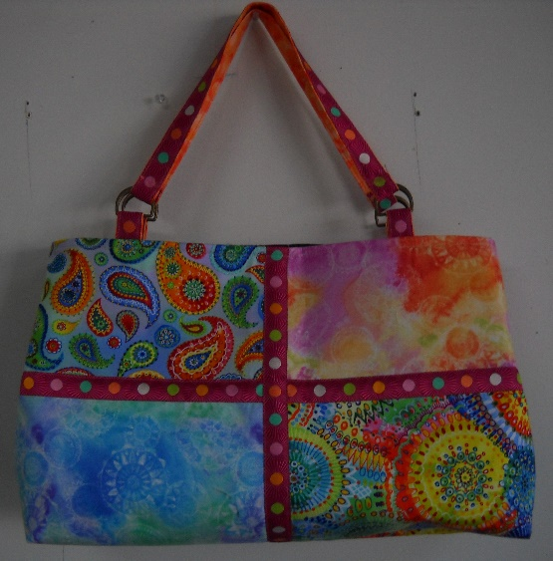
ALL SUPPLIES ARE AVAILABLE AT PIECEFUL QUILTING
Fabric:
4 different coordinating Fat Quarters
1 ½ yards for lining
4 yards of 7/8 inch ribbon for trim
1 3/8 yards mid weight fusible interfacing Décor Bond
1 3/8 yards extra firm stabilizer (sew in) Peltex

Equipment:
Rotary cutter and Mat
Clover 1 inch Create a strap
(4) 1 ¼ inch D rings or Rectangle rings
(3) magnetic snap closures
Wonder clips
Matching threads

CLASS POLICY
Payment is required upon registration. Store credit is given for any class you cannot attend only if Pieceful Quilting is notified one week prior to the class, afterward only if a replacement student can be found. No store credit will be given to students who cancel less than one week before class for any reason. Be sure to pick up the items on your supply list prior to class so you can be prepared with supplies and fabrics. Supply lists will be distributed when you register for the class. For classes cancelled by Pieceful Quilting you will receive a store credit or refund by check.

