Entry Line Up Number

PEACH DAY PARADE ENTRY FORM
Theme:
How the pandemic has brought my family closer?
-or-
How I’m surviving COVID?

We would like to extend a personal invitation to you and anyone else in your organization to participate in the Peach Days Parade on Saturday, September 12, 2020 at 9:00 p.m. Line up can begin at 8:00 p.m Please fill in the information and return entry form by September 8th to Ferron City Hall, P.O. Box 820, Ferron, Utah 84523, ferroncity@ferroncity.org, or fax to 435-384-2557. Keep the attached map for line up instructions.

Name or Organization Name

Contact Person or Organization Mailing Address P.O. Box City State Zip

Phone Email address
(Please provide for us so we can send your entry #)
Type of Entry

Float(s) Vehicle(s) Person(s) on foot Horse(s)

Please write in information that will help us in announcing your entry or message you may wish to give the audience. List names of individuals to be announced.

Special Parade Lineup Requests:

I will not hold Ferron City responsible for any harm or injury that may result in my participation in the Peach Days parade: (please sign) _______________________________________________________________

Ferron Peach Days Parade Line-up Instructions
(Keep for your Information)

The parade will be held Saturday, September 12, and will begin at the Emery County Nursing Home, 455 West Mill Road. Parade line-up will be at 8:00 to 8:30 p.m. The Parade will begin at 9:00 p.m.

New this year: Because of the current Coronavirus pandemic, there will be no candy, pamphlets, or other promotional items passed out. We’re sorry for this inconvenience but hope all enjoy this event anyway.
Also, if you have a vehicle pulling a trailer, float, etc. no one will be allowed to ride in the back of the vehicle. These rules are a mandate from our City insurance provider.

Please Refer to Map Below and Help Eliminate Confusion by Lining Up at the Following Locations:

Horses Please line up on the north side of 400 West and Mill Road. Be prepared to merge into parade at appropriate spots.

All other entries need to line up on Mill Road. Please travel up Canyon Road to 800 West, then proceed North on 800 West until you reach Mill Road. This will allow you to approach the Nursing Home from the West.
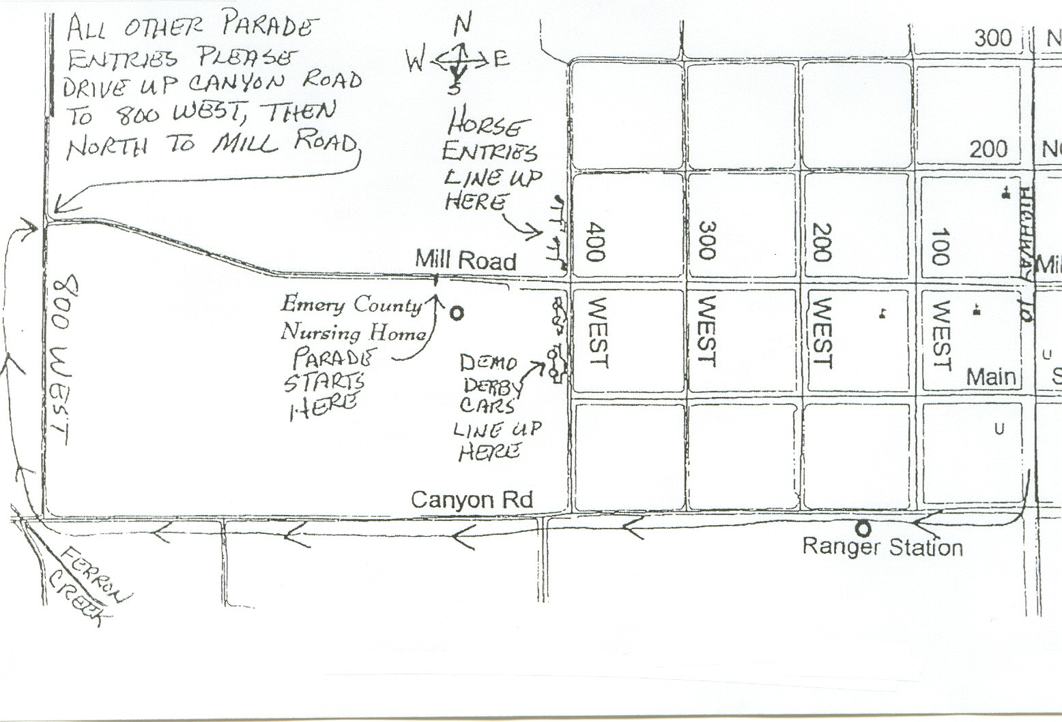
The parade will travel East on Mill Road, South on 100 West, North on Canyon Road, South on 400 West and end at San Rafael Middle School.

We would appreciate it if you would have your entry and parade participants there by 8:30 p.m. in order to be judged for awards.

Thank You,
Parade Committee

