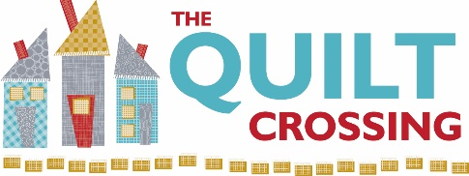

Class Name: Collage It! Pumpkins! Instructor: Laura Croft

Pre-Class Prep: Trace pattern on Pattern Ease foundation using black Sharpie pen

Supplies Required: (please provide brand if possible)

- ‘Whatevers! #22 Pumpkins 8 inch Block Collage’ pattern by Laura Heine
- Selection of cotton and/or flannel scraps for backgrounds, cuttables, and underlays
- 12 x 12”” piece of Pattern Ease foundation
- 1 yard of Steam-a-Seam 2 Fusible 12” wide
- Black Sharpie Pen (fat point)
- Applique’ Pressing Sheet
- Karen K Buckley Perfect Scissors (medium fine point, light blue handle)
- Large press pad and iron
- Ruler, rotary cutter, and cutting mat
- Notebook and pen for taking notes

Optional but helpful supplies:
- ‘Laura’s Little Book of Collage’ by Laura Heine
- Fabric glue (permanent adhesion, not basting glue)

Sewing Machine Needed for Class? No

We appreciate it when you buy your class supplies from us - these purchases enable us to offer a robust class schedule and keep your dollars local.

Cancellation Policy: We must commit to our teachers and to other students one week before the class begins so we can’t give refunds or transfers after that time (unless we can fill your spot from the waiting list). You are welcome to send someone in your place if you are unable to come. If enrollment has not met the minimum required for the class, we will cancel it one week before the first session. We love your kids but your fellow students left theirs at home and hope you will too.

Class Date(s): (1 session) Class Time(s):

