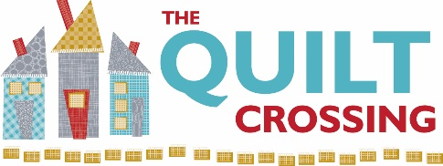

Class Name: “Ferris Wheel” Instructor: Carolyn Hutchinson

Supplies Required:
Fabric Requirements Crib/Throw (12 Blocks) Twin (30 Blocks)
Focus Fabric Partial Layer Cake or 1 yard Layer Cake or 2 1/2 yard
Contrast/Background 1 yard 2 1/2 yard
Sashing 3/4 yard 1 2/3 yard
Corner Stones 1/4 yard 1/4 yard
Border(s) 1 yard NA
Ruler –6” x 24”– Strongly Recommend Quilters’ Select
Square Ruler – 12” or larger - Strongly Recommend Quilters’ Select
Rotary Cutter with new/sharp blade – Recommend Quilters’ Select
Rotating Mat or small mat (i.e., 12” x 18”)
Cutting Mat
¼” Presser Foot
Wonder Clips – minimum of 2 colors – small pack is sufficient
Grippy for all rulers that are not Quilters’ Select
Best Press
Small Iron and Mat
Sewing machine in good working order plus favorite notions including:
Pins
Scissors and/or thread snips
Thread and bobbins– Recommend Aurifil
Seam Ripper – just in case
Optional but helpful supplies:
Additional ruler – 3” x 12” or 6” x 12” – Recommend Quilters’ Select
120” Tape Measure
We appreciate it when you buy your class supplies from us - these purchases enable us to offer a robust class schedule and keep your dollars local.
Cancellation Policy: We must commit to our teachers and to other students one week before the class begins so we can’t give refunds or transfers after that time (unless we can fill your spot from the waiting list). You are welcome to send someone in your place if you are unable to come. If enrollment has not met the minimum required for the class, we will cancel it one week before the first session. We love your kids, but your fellow students left theirs at home and hope you will too.
Class Date(s): Class Time(s):
November 17 , 18 & 19, 2022 10:00 a.m. to 4:00 p.m. each day

