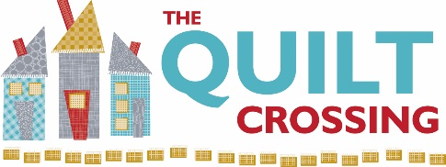

Class Name: “Baby Steps” Instructor: Carolyn Hutchinson

Supplies Required:
Pattern: “Baby Steps”
Fabric Requirements: -
See Pattern Back for Fabric Requirements

Ruler –6” x 24”– Recommend Quilters’ Select
4 ½” square ruler – Recommend Bloc_Loc
Rotary Cutter with new/sharp blade – Recommend Quilters’ Select
Cutting Mat
Best Press
¼” Presser Foot
Wonder Clips
Small Iron & mat

Sewing machine in good working order plus favorite notions including:
Pins
Scissors and/or thread snips
Thread and bobbins– Recommend Aurifil
Seam Ripper – just in case

Optional but helpful supplies:
Rotating Mat
Additional ruler – 3” x 12” or 6” x 12” – Recommend Quilters’ Select
Grippy spray if you don’t use Quilters’ Select rulers

We appreciate it when you buy your class supplies from us - these purchases enable us to offer a robust class schedule and keep your dollars local.

Cancellation Policy: We must commit to our teachers and to other students one week before the class begins so we can’t give refunds or transfers after that time (unless we can fill your spot from the waiting list). You are welcome to send someone in your place if you are unable to come. If enrollment has not met the minimum required for the class, we will cancel it one week before the first session. We love your kids, but your fellow students left theirs at home and hope you will too.

Class Date(s): Class Time(s):
April 3, 2023 10:30 am -5:30 pm
OR
June 22, 2023 10:30 am -5:30 pm

