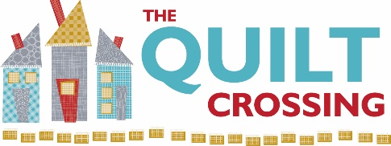

Class Name: Introduction to Embroidery Seasonal Dish Towel Instructor: Laura Schmidt

Pre-Class Prep: Photocopy desired Bareroots embroidery pattern onto Printable Stick ’n Stitch by Sulky, per package instructions.

Supplies Required: (please provide brand if possible)

- Bareroots seasonal embroidery pattern of your choice
- Printable Stick ‘n Stitch by Sulky
- Flour sack towel or vintage striped towel
- Selection of Weeks Dye Works thread
- Embroidery needle
- Embroidery hoop
- Press pad and iron
- Small scissors for snipping

Optional but helpful supplies: Notebook and pen for taking notes

Sewing Machine Needed for Class? No

We appreciate it when you buy your class supplies from us - these purchases enable us to offer a robust class schedule and keep your dollars local.

Cancellation Policy: We must commit to our teachers and to other students one week before the class begins so we can’t give refunds or transfers after that time (unless we can fill your spot from the waiting list). You are welcome to send someone in your place if you are unable to come. If enrollment has not met the minimum required for the class, we will cancel it one week before the first session. We love your kids but your fellow students left theirs at home and hope you will too.

Class Date(s): (1 session) Class Time(s):

