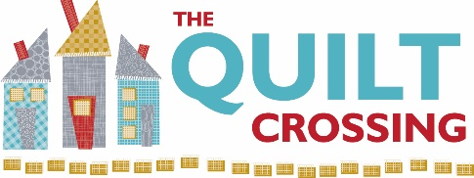

Class Name: Embroidered Coiled Rope Bowl and Coasters Instructor: Sandy Lieske

Supplies Required:
- Sewing machine capable of at least a 5mm wide zig-zag stitch, appropriate foot and other accessories (cord, foot pedal, extension table, and knee lift)
- Embroidery module
- USB stick
- Size 90/14 Jeans, Microtex , or Topstitch sewing machine needles
- 100 foot package of cotton clothesline rope, rolled into a ball
- Aurifil thread in a neutral color to match your rope color as you will see this stitching
- Aurifil thread in constrasting colors if you want to embellish your bowl or coasters
- Bobbins wound with same neutral color thread
- Fabric scraps if you want to embellish your bowl or coasters
- Aqua Mesh stabilizer for embroidery
- Embroidery thread to match the designs you wish to embroider on your project
- Large Oval or Midi hoop
- Sewline fabric glue pen
- 505 Adhesive
- Aleene’s Stiffen Quik if you wish to stiffen up your bowl
- Seam ripper
- Pins

If you have any questions regarding the class preparation, please contact me directly at: 208-5703290.

Cancellation Policy: We must commit to our teachers and to other students one week before the class begins so we can’t give refunds or transfers after that time (unless we can fill your spot from the waiting list). You are welcome to send someone in your place if you are unable to come. If enrollment has not met the minimum required for the class, we will cancel it one week before the first session.

