Tea Light Holder Supply List 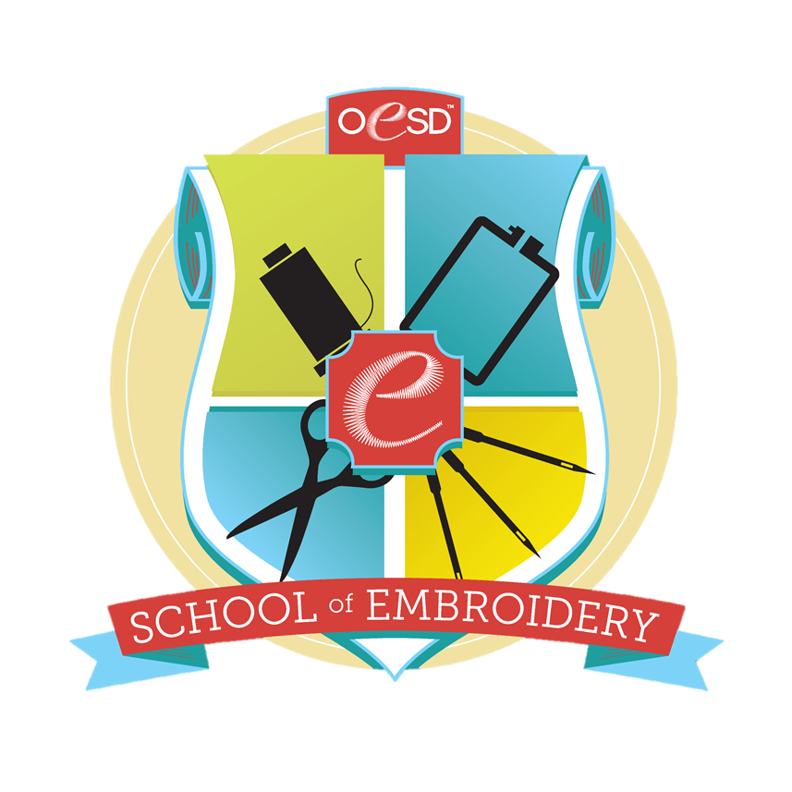
Stabilizers:
2 sheets Aquamesh 10” x 15”
2 sheets Badgmaster 10” x 15”

Threads: same threads will be used in bobbin as well.
Isacord white 0015
2 Isacord colors of your choice that blend for background. Sample used 4421 and 4430

Other supplies:
Machine with embroidery module
Power cord
Foot Control
Slide on Table
Free hand System
Straight Stitch Plate
#26 Embroidery Foot
3 bobbins with needle thread wound on.
Embroidery Needles, size 75
Thread Snips
USB for class folder, embroider design will only be loaded directly to machines.

