Designs by JuJu Eloise Pillow Class Description
Class Dates: Saturday July 19th and August 16th from 9:30 AM to 2:00PM
Cost for Class: $40.00
Design and USB stick: $12.00
This pillow is embroidered using the tack and trim applique technique layered on a backing fabric. The pillow can be made in 5 different sizes and you can choose the size that will fit in your machine’s hoops.
12” (6X6) – Small Clamp, Mega, and Midi
14” (7X7) – Medium Clamp, Maxi
16” (8X8) – Medium Clamp, Maxi
18” (9X9) – Jumbo Hoop
20” (10X10) – Bernina Giant Hoop
The first class will cover stitching out one quarter of the design and the other three quarters will be done by you at home.
The second class will cover stitching the 4 quarters together to make the front of the pillow, making the piping and putting the pillow together.
The entire design with instructions will be purchased and downloaded and given to you on a usb stick at the start of class. This is a licensed product and cannot be shared. Please make a backup copy of the design in case something ever happens to your USB drive.

Designs by JuJu Eloise Pillow Class Supply List

Please bring the following:
- Your machine in good working order with embroidery module and hoops
- Several bobbins to fit your machine that are wound with bobbin thread
- A new 90/14 embroidery needle installed an extras in case of breakage
- The embroidery foot for your machine
- Feet to sew straight ¼” and ½” seams
- Snips and additional scissors for trimming the appliques if you prefer not to use your snips,
- Embroidery tape
- No-Show Mesh cut away stabilizer in a size to fit the hoop you will be using,
- Wonder clips and pins
- Pillow form to fit the size pillow you are making
- Any additional supplies you usually use when embroidering
You will purchase the fabrics you wish to use for the size pillow you are making as listed in the Supply List Fabric Cutting chart below multiplied by 4. The cutting chart only specifies the fabrics for one quarter of the pillow and to make the entire pillow front you need to make 4 quarters. Please multiply the Fabric, Batting, ShapeFlex (SF101) and No-Show Mesh cut away stabilizer amounts by four. You will only put the ShapeFlex on the back of the background fabric pieces as that will help prevent puckering as you layer the appliques on top of the background fabric.
You will need a total of 11 spools of Isacord or Mettler polyester embroidery thread to embroider the pillow. You will need 9 spools to match the colors of the 9 applique fabrics you chose for your pillow as shown on the Fabric Design Placement Map below, 1 spool in a color you choose for the background quilting, and a neutral color thread to use in the placement of the applique fabrics.
We will be making the envelope style backing for the pillow so please reference the Backing Fabric Chart below for the amount of fabric needed for the size pillow you are making. If you wish to make piping for your pillow, please bring an additional 1/4th of a yard of coordinating fabric. Please do not cut out the backing and piping fabric until after the first class. I will supply the cording for the piping.
Below is a picture of the pillow front of the class sample:

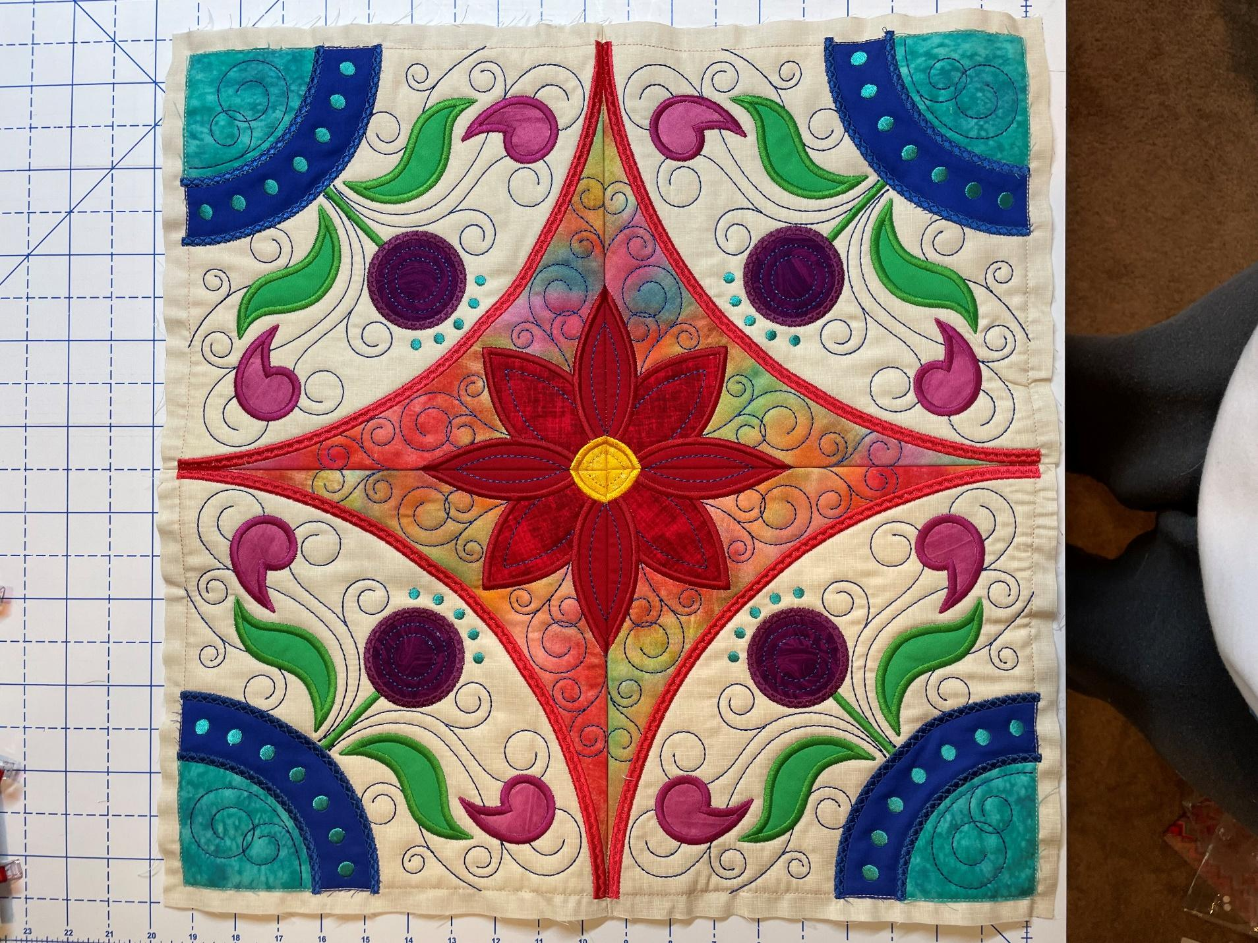
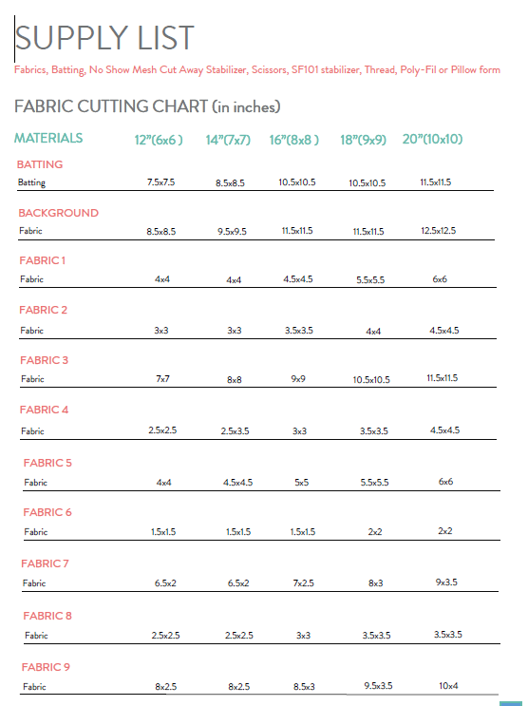

*Note: SF101 added to background fabric to prevent puckering when stitching out applique pieces to the blocks.
*Note: We highly recommend choosing tone-on-tone fabrics with subtle patterns for the applique portions.
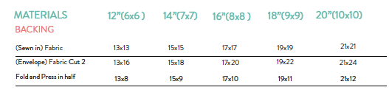
Fabric Design Placement Map
