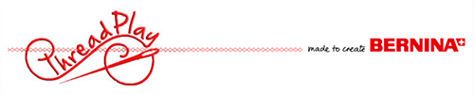

Supply List

IN THE HOOP KITCHEN JAR LABELS
Instructor: Theresa Hubbell
In the hoop projects are so fun and easy to make! Jar toppers and gift tags are perfect for gift giving. They make the perfect topper for canned goods, jellies and jams, or even mason jar cookie mixes. The project to be made in class is a topper for a wide mouth mason jar and a cute little tag to go with it. Embroidery on cork is a snap using water soluble stabilizers.
The bonus designs include a blank jar topper and tag. Your embroidery machine makes it so easy to customize a design by adding lettering. The possibilities are endless!
KIT $ for stabilizers, cork and thread
Here’s what you’ll need…
**Sewing machine with embroidery module, medium hoop and All your favorite sewing notions such as scissors, tweezers, seam ripper, needles, chalk marker or pencil AND #26 foot .
USB stick to save designs

Any questions? Please feel free to call or stop in!
**Available at Thread Play
Please arrive 10-15 minutes early to set up and be prepared to start at designated time.
Cancellation Policy: If you withdraw from a class, a store credit will be given with a five day minimum notice prior to class date. If Thread Play cancels a class, you will be given the option of a refund or a store credit.

Thread Play with Bernina
(303)BERNINA
www.Threadplay.net

