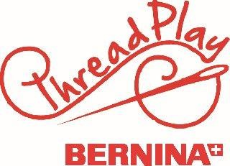
Midi Bag Supply List
Instructor: Charla Gee

Fabric:
Outer squares and Handle takes 10 strips (2.5” wide by at least 40” in a variety of fabrics)
There are (108) 2.5” squares, made from 8 strips.
*Can use (1) 42 pack of Charm packs for one bag
Outer Handles made from 2 strips of fabric
Bag Lining and Handle Lining Fabric: ¾ yard

Optional: Fusible Fleece ¾ yard- Available at Thread Play
Sewing Machine and basic accessories, including a ¼” presser foot.
Optional- Rotary Mat, Rotary cutter, sewing pins, small scissors, fabric marking tool

For Class, please come with 108 squares- 2.5”precut.

