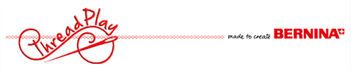

Supply List

Ebony Knit Dress/ Tee

Here’s what you’ll need…
-Pattern*
-Jersey/ stretch Needle*
-Polyester Thread*
-1/4” wide clear elastic
OPTIONAL- Twin Needle to finish hems.*
-Fabric (use attached size chart to choose how much fabric needed)
Fabric Recommendations:
Light to medium-weight drapey knits with at least 30% crosswise stretch, such as rayon, cotton, silk & linen jerseys, and ITY.

*Items that are available for purchase at Thread Play.
