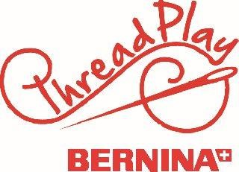

Braid Runner
“Quilt as you go”
Instructor: June Greinman
Supply List

-Machine and basic accessories, including scissors, seam ripper, marking pens etc.
-Presser feet, including 1/4” foot, general sewing foot.
-Pattern
-Material- Center square of at least 6”, 1/8 yard of 6 fabrics
-Borders- ½ yard of two fabrics
-Batting and Batting- At least 20” X 60” pieces

