ATLANTIS BOM – 14 MONTHS: 12 BLOCKS PLUS 1 BORDER SETTING

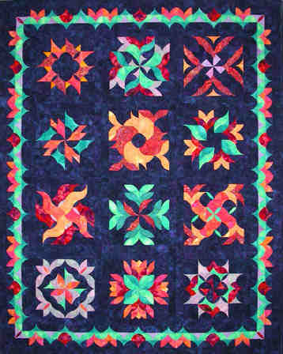

This stunning 60” x 75” Block of the Month quilt is a great way to kick off the New Year with a great project! Each block has a great water name that adds to this unique “water” piece. Come explore the depths of the ocean!

Supplies-
- Sewing machine
- Basic sewing supplies
- Stiletto
- Marking pen or graphite pencil
- At least three wound bobbins (thread to match your fabric), thread for sewing
- Rotary cutter and ruler 24” ruler – definitely 12” ruler - very helpful
- 12” square
- 6” square helpful
- Roxanne’s glue and a couple round toothpicks
- Baggies (quart size) and fine point marking pen
- Fabric cut and ready to go for the class (a material supply list and any additional items will be provided before the class).
- Sticky note pad

Fabrics
You can purchase the amount of fabric you need in each color or you can use scrap fabric you have in your fabric collection. I am including a chart with the total fabric requirements by block so if you choose to use scrap fabric, you will know what you will need for each block.

Supply list for month one (Seaweed):
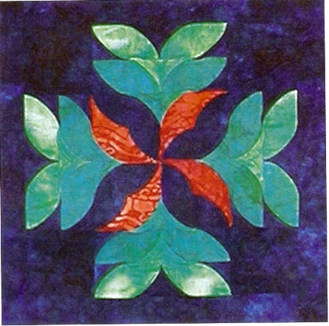

Background fabric (Sea Blue) – 1/3 yard for Seaweed block
6 yards total for the entire quilt
- You can use a different background for each block 1/3 yard each month for each block and 2 yards for the border or you will need 6 yards of the same background for the entire quilt. A dark blue is what I am using that gives the sense of water. You can also use a green or other color of your choice for the background.

Light Green – 1/8 yard for Seaweed block

Aqua – 1/8 yard for Seaweed block
- 1 yard needed for entire quilt

Coral I – 1/8 yard for Seaweed block
- ¾ yard needed for entire quilt

