Miss Matilda Dress
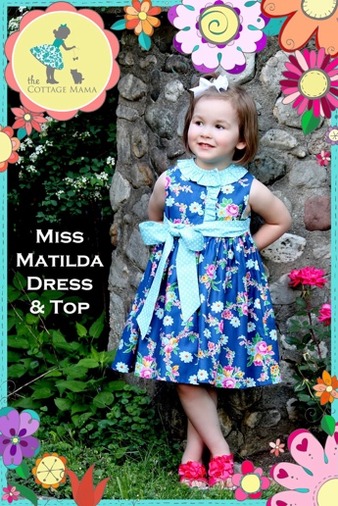 | Miss Matilda Dress and Top can be casual for every day or dressed up for special occasions.  The sleeveless dress or top has a button front, fully lined bodice and gathered skirt attached at the waistline. Optional ruffles and waistline sash.  The neckline has a bias binding, but you’ll also learn an alternative neckline finish, without the bias binding, to fully enclose the bodice.  Someone will have a beautiful dress or top to dance in!

Supply List:
- Pattern: Cottage Mama – Miss Matilda Dress & Top
- Fabric: Woven cotton - Prewashed before class*
- Matching thread
- Buttons: ½” to ¾” – 3, 4, or 5 depending on dress size
- Double fold bias tape (either purchased or pre-made by you)
- Lunch: please bring lunch with you so we don’t get grumpy

Tools:
- Fabric shears
- Paper scissors (for cutting out the pattern)
- Small scissors or thread snips
- Fabric measuring tape (not one from the garage)
- Straight pins
- Fabric marking pen or pencils
- 6” seam gauge
- 12” or 18” clear gridded ruler
- Seam ripper
- Pinking shears

To make the best use of class time, please cut the pattern and fabric before arriving to class.

*Due to fabric shrinkage, excess dye, & starch applied during manufacture, it’s essential that the fabric is washed and dried before coming to class. Fabrics can shrink up to 25%, sizing, or starch, can change the “hand” of the fabric considerably. Launder the fabric in the same way you plan to launder the finished garment. Be careful to wash with similar colors in case the dye bleeds!
The store sample of this dress is a size 6, view C. It uses a border print fabric which may require additional yardage. Talk to Kimberly or Melissa, they will help you with calculations.

