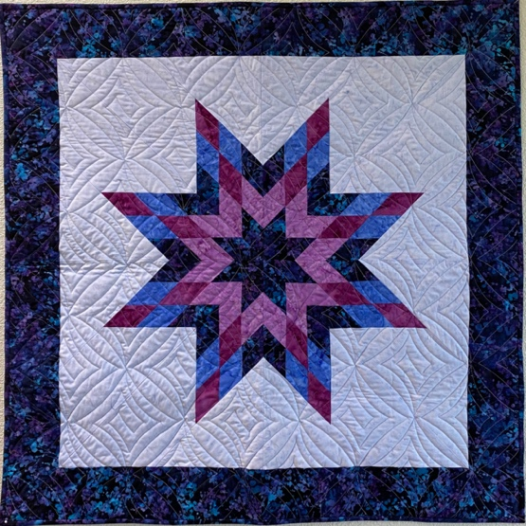
Patterns by Quiltworx, Inc. - Designed by Judy Niemeyer
Starbaby
Quilt
32”x32” or
40”x40”
Instructor:
JudyQ Block
JudyQ Block – judy@judyqblock.com – 503-780-9339 (leave message or text is best)
www.JudyQBlock.com – Join Us at our Facebook Group: https://www.facebook.com/groups/SharingOurQuiltingPassions
Aloha Sewing & Vacuum Center – 7550 E Main St., Hillsboro, OR 97123

Basic Sewing Supplies: Steam iron, ironing board, large size cutting board, 6” by 24” ruler, small scissors, rotary cutter (recommend 60mm or 45mm as you cut thru several layers of fabric), seam ripper, and a sewing machine in good working condition with a quarter-inch foot

Paper Piecing Supplies: 12” Add-A-Quarter ruler, Scotch tape (or washi tape as it can take the heat of your iron),
Fabric glue stick (UHU, Elmer’s Craft Bond), washout fabric glue pen (refillable, brands ie: Sewline, Bohin, Quilter’s Select are universal) plus refills, and a repositionable glue stick (Scotch Restickable), Plastic fold template (3-1/2” x 12” Size approximate) I cut mine from quilters template plastic), flower pins, 3-4 large Ziploc bags (I prefer 1gal), labels and felt parker (to mark bags), a Purple Thang (I also use a double pointed bamboo stiletto), size 70 sewing needles, a high-quality cotton thread, paper clips (extra large) and binder clips (I use both small and medium).. and the Quiltworx pattern and fabric you have selected.
*note – you are welcome to alter your colorway and placement.

This 32”x32” Starbaby Quilt can easily transform into a 40”x40” baby quilt by just adding a border. Diameter. This is a great introduction piece to the world of Judy Niemeyer. Imagine the possibilities with colors with this design, and great for using up scraps or remaining 2 ½” strips.

Quick and Easy Foundation Paper Piecing project. You can sign up for a 7day free trial with the promo code TRIAL7
requirements if not using Quiltster. You will need to bring at least 9 strips x WOF (that coordinate in color Bight to Darks) to create the Lone Star JudyQ with questions. Plus 3/4yd for background, and 5/8yd for optional border. Backing = 1 1/8td or if using optional border make that 2 3/4yds. Binding.. 3/8yd.
Pattern avail at Class $20.50
Part 1 of 2
Techniques we’ll learn:
Preparing papers
Learn paper piecing basics
Color placement, Fabric Charts, Fabric Cutting
Sorting, Stacking and Organization
Strip Piecing

Part 2 of 2
Review homework
Assembly of Lone Star Diamond
Background
Borders
Assembly of topper
Binding

