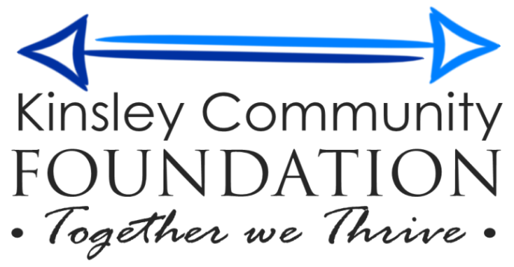

October 8, 2019

RE: Kinsley Community Foundation Grant Opportunity
The Kinsley Community Foundation is releasing this request for proposals for Kinsley organizations to compete for $385 in grant funds that will be awarded in November 2019. The Grant Application is enclosed. Incomplete applications will not be reviewed. Applications are due by November 1, 2019.
Eligible applicants include any governmental, educational, or nonprofit organization in Kinsley, KS. Applicants do not have to have 501(c)3 status in order to apply. The intention of the Foundation is to fund or partially fund a project, not ongoing administrative costs. Questions about the application can be directed to Linette Miller at 620-659-2711.
Finished applications should be received by the Foundation by 5:00 P.M., on or before November 1, 2019. Applications can be mailed to: Kinsley Community Foundation, PO Box 161, Kinsley, KS 67547, emailed to ecedc@sbcglobal.net, or dropped off at the Edwards County Economic Development Office, 721 Marsh Ave., or the Edwards County Extension Office, 212 E. 6th.

