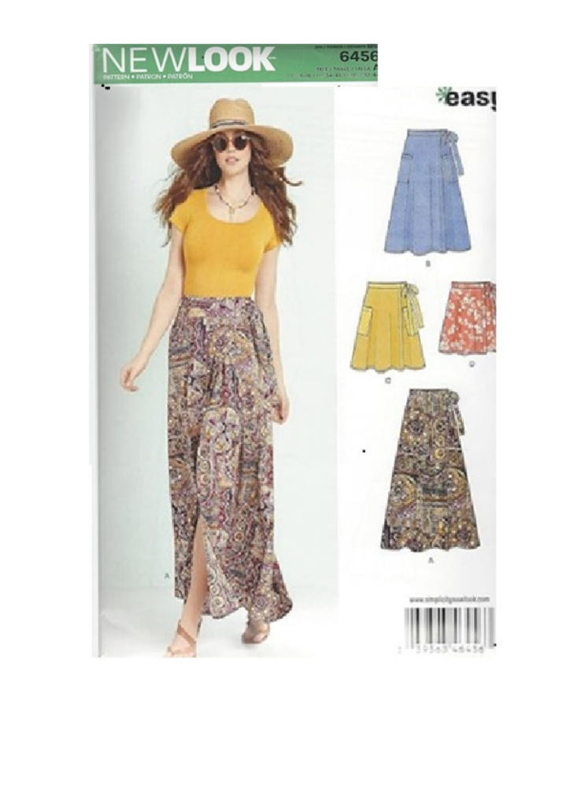

Imagine a skirt that takes you from the school run, to the gym, running errands, and lunch out with gal-pals! 100% made by YOU! Join us to make an easy-wearing skirt, in your choice of four lengths.

No fiddling, no fitting. Make, slip on and Go!

Look how easy!!!

See you in class!

**You will need the following for class:**

* A working sewing machine
* Pattern New Look 6456 – **to be ordered on line and have it ready for class**

<https://simplicity.com/new-look/n6456?searchid=20623339&search_query=new+look+6456>

* Fabric – AAA Sewing and Fabric has several fabrics perfect for this skirt: batik and cotton. Depending on chosen length and size, fabric in the amount of 2 – 5 yards, plus a bit of interfacing (look at the back of the pattern envelope) - We appreciate the support!
* NO zipper, NO buttons, NO fuss!
* Fabric - per pattern (we have 100% cotton fabric at AAA Sewing)
* Thread to match your fabric