Quiltworx Basics

Learn the basics of a Quiltworx pattern in this one day class. I will walk you thru reading, cutting, and sewing this beginner Quiltworx pattern.

Requirements:
- Pattern Broken Daisy
- Fabric of your choice. Listed on back of pattern

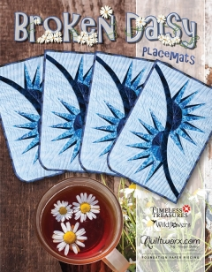

General Supply List

- 6”X12” Rotary ruler or 6”X24”
- Rotary cutter with new blade
- Medium Cutting Mat - 12”x18”
- Sewing machine in good working order including foot pedal and power cord
- ¼” piecing foot
- Open toe foot
- High quality cotton thread and several wound bobbins (size 50 or 60 thread)
- Seam ripper
- Pins
- Size 70/10 sewing needles-microtex

Paper Piecing
- Large uncoated paper clips (100)
- Gallon size zip lock bags
- Template plastic approx. 3” X 10” (folding template)
- Add-A-Quarter 12” or 18” ruler
- Fabric glue stick

- REMINDER: Class Policies: Payment is required at the time of registration. Classes may be cancelled if the teacher minimum is not met. Refunds or credits will be given if a class is cancelled. If you are unable to attend a class and are not able to call seven days before the start of a class, you will be given a store credit only. If you cancel or don't show the day of class-THERE IS NO REFUND OR NO STORE CREDIT. We have had to compensate our teacher. Plan on bringing your lunch.

Class:
September 24, 2022
10:00 – 4:00
$40.00
Ann Troutman

