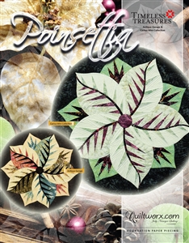
Poinsettia – Fall 2020
The Poinsettia pattern is a great place to start if you have never sewed a Judy Niemeyer foundation paper pieced project before. You will learn the basic techniques and skills including cutting techniques, the language in the pattern, how to paper piece and how to sew an “S” seam. Come join the fun

Most of the required items listed below are available at Sweet Darling Quilts and you will receive a 10% discount. If you have any questions about any of these items, please give the store a call. For help with color ideas, Ann works most Tuesdays and can help you decide
Quiltworx Pattern – Poinsetttia and Fabric requirements on back of pattern
General Paper Piecing Supply List
- Paper scissors
- Large uncoated paper clips
- 8 – gallon size zip lock bags
- 6”X12” Rotary ruler or 6”X24”
- Rotary cutter with new blade
- Medium Cutting Mat - 12”x18”
- Template plastic approx. 3” X 10” (folding template)
- Sewing machine in good working order including foot pedal and power cord
- ¼” piecing foot
- Open toe foot
- High quality cotton thread and several wound bobbins (size 50 or 60 thread)
- Small scissors
- Seam ripper
- Add-A-Quarter 12” or 18” ruler
- Scotch Tape
- Fabric glue stick or Washout fabric glue pen
- Flower pins
- Purple thang
- Size 70/10 sewing needles-microtex

- REMINDER: Class Policies: Payment is required at the time of registration. Classes may be cancelled if the teacher minimum is not met. Refunds or credits will be given if a class is cancelled. If you are unable to attend a class and are not able to call seven days before the start of a class, you will be given a store credit only. If you cancel or don't show the day of class-THERE IS NO REFUND OR NO STORE CREDIT. We have had to compensate our teacher. Plan on bringing your lunch.

Friday, Oct 16 & Nov 6
10:00-4:00
$80.00
Ann Troutman

