Northern Star Apprentice Class

Great beginner table topper. Learn to cut fabric and paper piece the Quiltworx way.

I will be piecing one right along with you so you can see how quick and easy it is.

Fabric Requirements
Main Star – ½ yd
Accent Star – ¼ yd
Background – ½ yd
Background Accent – ¼ yd

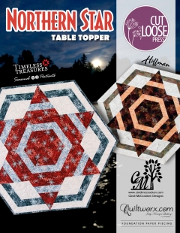

General Supply List

- 6”X12” Rotary ruler or 6”X24”
- Rotary cutter with new blade
- Medium Cutting Mat - 12”x18”
- Sewing machine in good working order including foot pedal and power cord
- ¼” piecing foot
- Open toe foot
- High quality cotton thread and several wound bobbins (size 50 or 60 thread)
- Seam ripper
- Pins
- Size 70/10 sewing needles-microtex

Paper Piecing
- Large uncoated paper clips (100)
- Gallon size zip lock bags
- Template plastic approx. 3” X 10” (folding template)
- Add-A-Quarter 12” or 18” ruler
- Fabric glue stick

- REMINDER: Class Policies: Payment is required at the time of registration. Classes may be cancelled if the teacher minimum is not met. Refunds or credits will be given if a class is cancelled. If you are unable to attend a class and are not able to call seven days before the start of a class, you will be given a store credit only. If you cancel or don't show the day of class-THERE IS NO REFUND OR NO STORE CREDIT. We have had to compensate our teacher. Plan on bringing your lunch.

October 24, 2020
10:00-4:00
$109.00 (this includes pattern, papers and $50.00 store credit)

Ann Troutman

