TRIANGLES
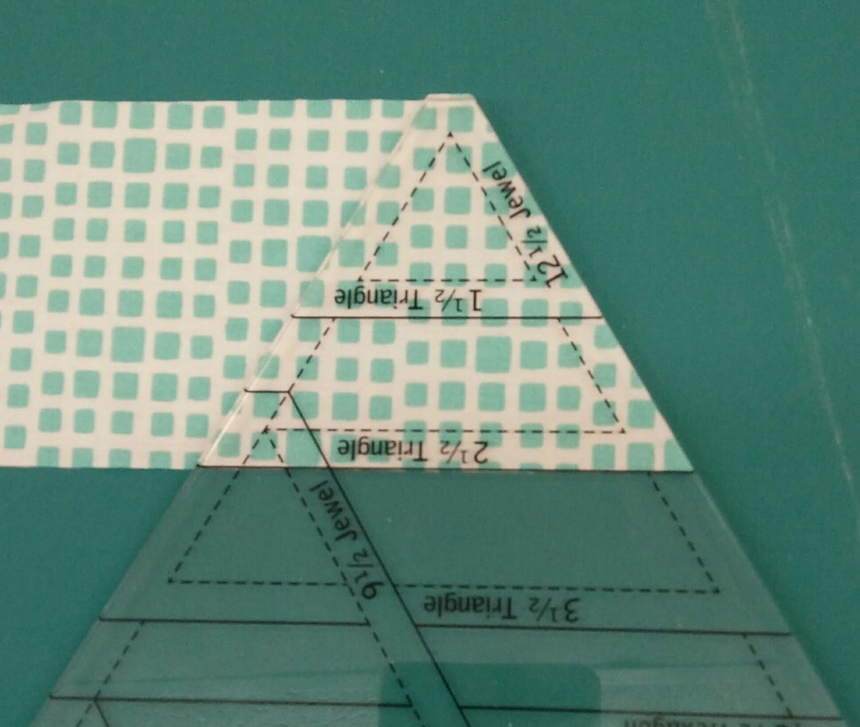
Place the ruler on the correctly cut width of fabric. The raw edges of the fabric will align with the top blunted edge of the triangle and a line on the ruler along the bottom edge of the strip as shown. Cut along the right edge of the ruler.

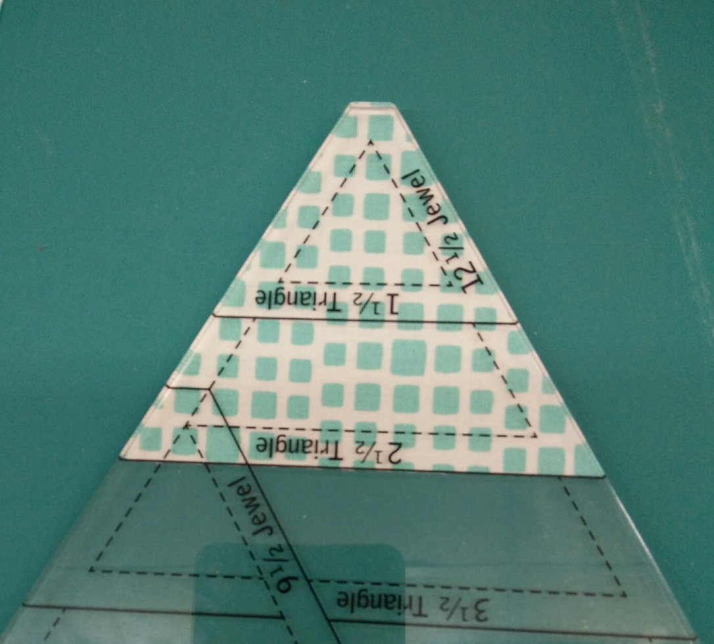
Flip the mat and cut along the second edge to complete the triangle shape.

In this Block of the Month, triangles of several sizes will be cut in this manner. The strip should always be cut to the width required first before proceeding to cut the shape.

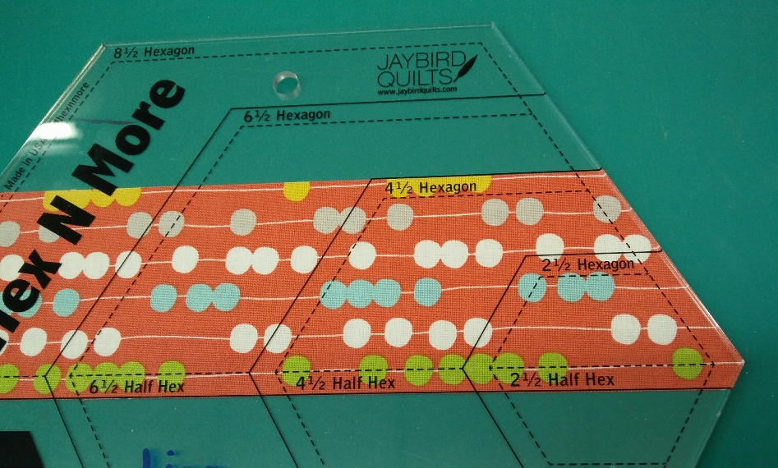
HALF HEXAGONS
As with the triangles, the fabric strip must first be cut to the width needed. For the 4 ½ inch half hexagon a 2 ½ inch strip is needed. Once the ruler is placed on the ruler, the strips raw edges will meet the black solid lines of the 4 ½ inch half hex at the bottom and 4 ½ hexagon at the top. Cut the right edge as shown.

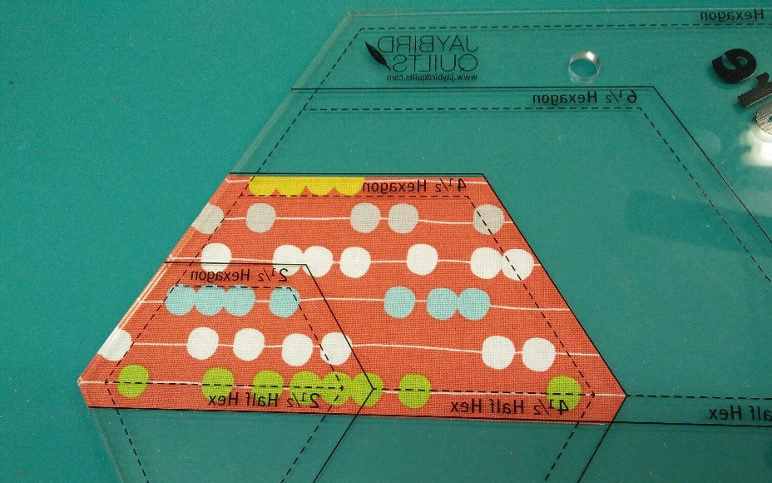
Flip the ruler, so that the previously cut edge is now on the black solid lines within the ruler and the left edge can now be cut along the edge of the ruler as shown below. Rotate the mat to make it easier to cut the second side of the shape.

MODIFIED HALF HEXAGONS
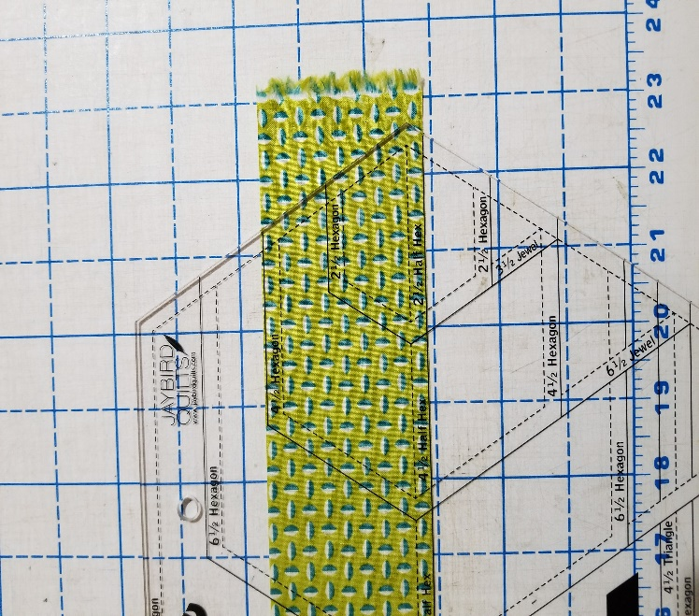 Again, cut the fabric strip the width needed. Place the ruler on the fabric. Align the bottom raw edge of the fabric with the black solid line marked as Half Hex as shown in the picture. Cut the right side of the shape along the right edge of the ruler
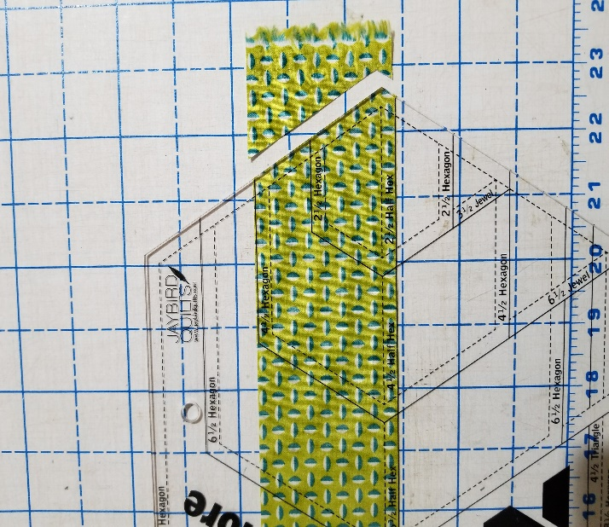

Flip the fabric. Align the previously cut edge with the black solid line corresponding to the 6 ½ Half Hex edge within the ruler and cut the left edge. Rotate mat as necessary.

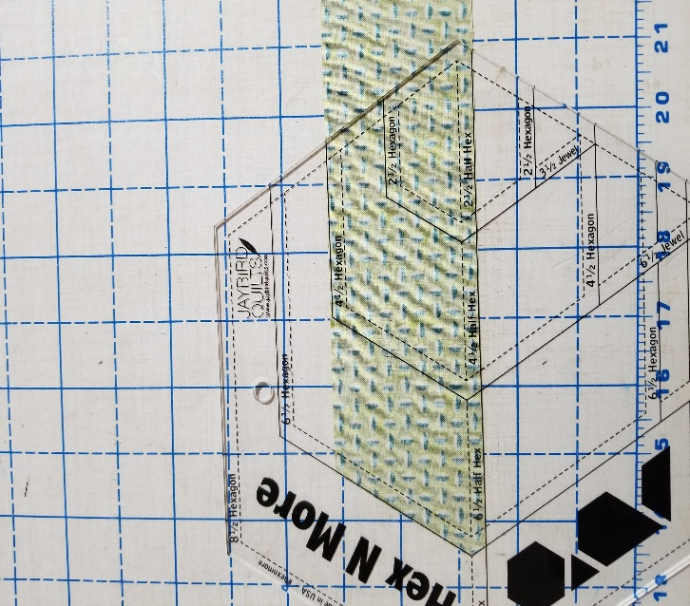
Notice that the final patch is the length of the 6 ½ inch Half Hex, but not the width.

