Introduction to Quilting Part 2 – Finishing Your Quilt

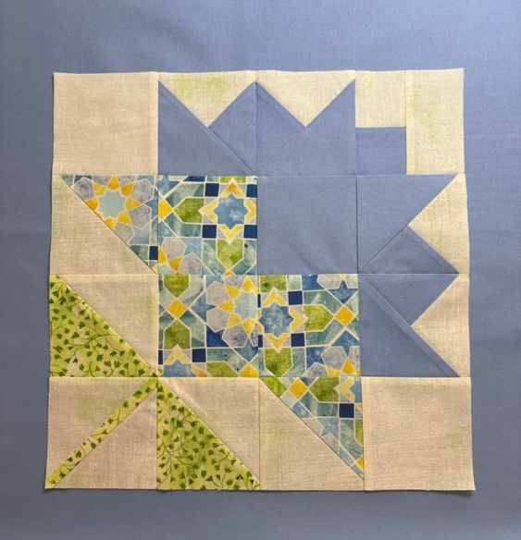
Sample 12” Block

Ready to finish your first quilt? Join Introduction to Quilting: Part 2 and learn the essential steps for bringing your quilt top together. This instructional workshop focuses on techniques for sashing, borders, binding and labels, with dedicated time at the end for hands-on sewing. Students who haven’t taken Part 1 are welcome and can practice the techniques using fabric yardage instead of completed blocks.

- Sashing: Learn how to frame and separate your quilt blocks for a flat quilt top.
- Borders: Discover how to measure, cut, and attach borders for a flawless frame.
- Binding: Master the process of finishing the edges neatly and securely.
- Labels: Learn how to create a personalized label for your quilt.

Bring with you
Quilt blocks ready to assemble into quilt: Bring loose blocks ready for sashing w/cornerstones and fabric for both (1 yd total). If you don’t have sampler blocks you can cut large scale fabric to use as blocks, or smaller “blocks” from a panel to learn sashing and cornerstones.
OR
Quilt top ready for borders: Something already pieced and pressed, or a large panel. Bring at least ½ yd for narrow border and closer to 1 yd for wide border & binding for Part 1 class sampler quilt.

Necessary tools:
- 45mm rotary cutter
- Rotary Cutting mat (self-healing 18”x24” Olfa recommended)
- 6”x24”quilting ruler (or similar size long ruler)
- 6½” x 6½” and 6”x12” rulers (or similar size)
- Scissors
- Seam ripper & Stiletto
- Pins (silk or patchwork pins = 0.5mm or 0.4mm fine) – I like Clover brand
- Acorn precision piecing starter kit (optional but incredibly helpful)
- Sewing machine…threaded, with full bobbin and fresh size 11 or 12 needle installed. You must know how to use and operate your sewing machine.
- ¼” foot for your machine (optional but incredibly helpful)

