Introduction to Quilting– with Jennifer Mellow

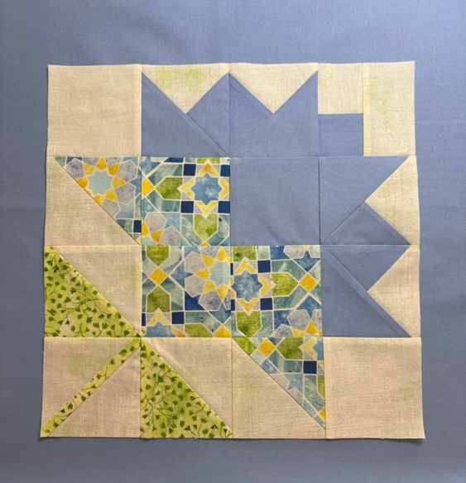
Sample 12” Block

This one-day class offers a comprehensive introduction to quiltmaking, with a focus on building accurate and efficient techniques from the start. We’ll focus on the basics with rotary cutting, understanding different block types, half square triangles, quarter square triangles, and sewing accurate blocks.

We will be making different units that can be assembled for quilt blocks as we learn techniques for traditional quilting. By the end of class, you will have the knowledge needed to make this sample block, but it is not the only possible product of this class.

Necessary tools:
- 45mm rotary cutter
- Rotary Cutting mat (self-healing 18”x24” Olfa recommended)
- 6”x12” or 6”x24”quilting ruler
- 6½” x 6½” ruler
- Scissors
- Seam ripper & Stiletto
- Pins (silk or patchwork pins = 0.5mm or 0.4mm fine) – I like Clover brand
- Acorn precision piecing starter kit (optional but incredibly helpful)
- Sewing machine…threaded, with full bobbin and fresh size 11 or 12 needle installed. You must know how to use and operate your sewing machine.
- ¼” foot for your machine (optional but incredibly helpful)
- 18” square of flannel on cardboard (or Design Board)

Fabric Needed for class
Cotton quilting fabric – bring ¼” yard each of background and 3 (or more) other fabrics
Yardage is better than fat quarters for this class
Solids, tone on tone, non-directional, small to medium prints recommended

