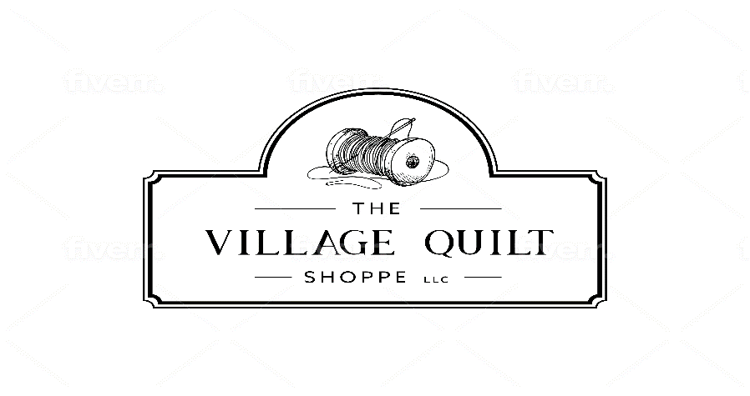
21 East Main St.
Webster, NY 14580
585-626-6916
https://thevillagequilt-shoppe

Welcome to The Village Quilt Shoppe; our classes are designed to ensure a fun, relaxing, and educational atmosphere. Come prepared to learn, sew and have fun!

Class: FPP DIY Fir Tree (Intermediate/Advanced)
Date/Time: December 3rd, 10:30-2
Instructor: Jane Beamish

Supply List (supplies bought at the shop will be 10% off):
- Fabric*
  - Several greens for tree- scraps and remnants are welcome
  - Small piece of brown (approximately 2” square) for a tree trunk
  - Background- half a fat quarter will be plenty
  - Border- half a fat quarter will be plenty
- Paper template will be provided by the instructor during the class
- Add-a-Quarter ruler* or Add-a-Quarter Plus ruler. If you happen to have both 6” and 12”, bring them both. We can work with either one, so bring what you have.
- A postcard. If you don’t have one, the instructor will provide one to you.
- Thread (suggested grey or green- whatever works with your fabric)
- Sewing machine with open-toe foot and size 90/14 needle
- Pre-wound bobbin
- Scissors for trimming threads
- Rotary cutter, rotary cutting ruler and rotary cutting mat
- If you have them, travel/mini iron and pressing surface.
- Seam ripper
- Pencil (not a Frixion pen)

Pre-work to be completed before class:

- Gather supplies and courage

Additional comments:

- This is a participation class.
- Each class member will need their own supplies and tools.
- Class will start at the designated time.
- You are welcome to come to the shoppe before class to purchase items, cut fabric, set up your machine, etc.
- In order to finish the project at home, you will need backing fabric, batting, and binding.

