Pink Grapefruit Shortbread Cookies
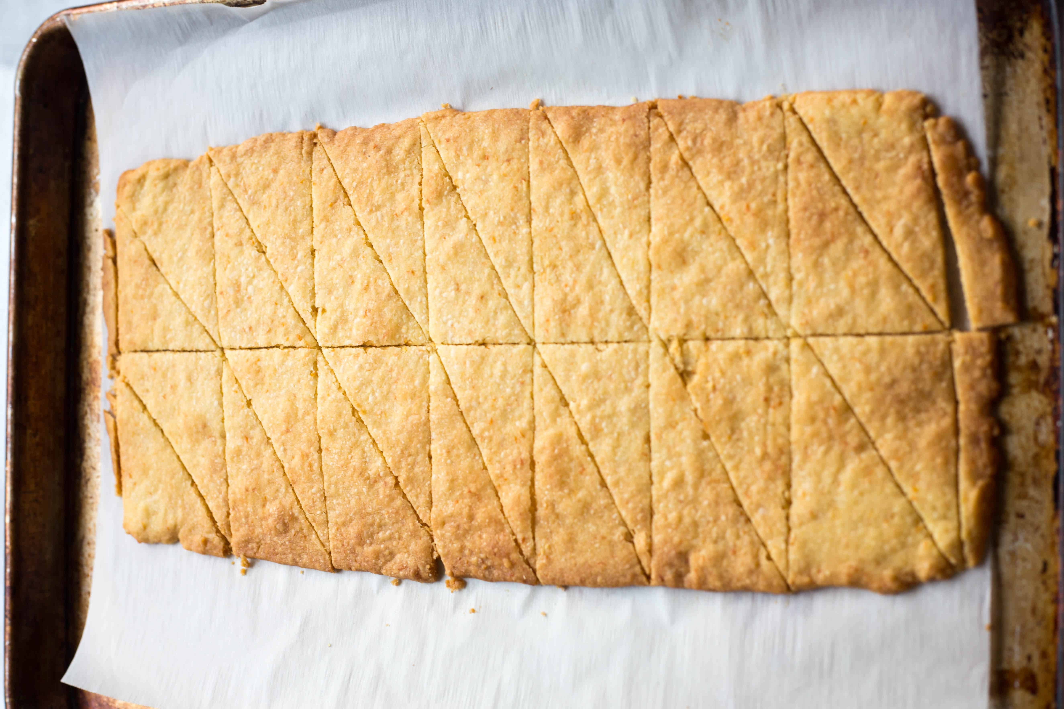
For the Shortbread:
½ cup unsalted butter
1 tablespoon finely grated grapefruit zest
1 teaspoon vanilla extract
⅓ cup powdered sugar
½ teaspoon Kosher salt
1 cup all-purpose flour

For the Topping:
1 tablespoon plus 1 teaspoon fresh grapefruit juice
½ teaspoon vanilla extract
⅛ teaspoon Kosher salt
¾ cup powdered sugar
Crushed pink peppercorns and/or pink sprinkles, sanding sugar, dried rose petals and/or dried hibiscus flowers (optional)

Instructions:
In the bowl of a food processor, add the butter, grapefruit zest, vanilla extract, powdered sugar and salt. Pulse until smooth and all ingredients are fully incorporated. Add the flour and pulse until just combined. Wrap the dough in plastic and chill for 30 minutes.
Preheat the oven to 350 degrees F. Roll the dough between two sheets of parchment paper until it's roughly 14" long by 7" wide. Carefully peel the top piece of parchment off and transfer the bottom piece with the dough to a sheet pan.
Bake for about 15-18 minutes or until lightly golden around the edges. Remove from the oven and immediately cut in half lengthwise (I use a pizza cutter), then cut crosswise 6 times to make 12 even rectangles. Then cut each rectangle into a diagonal to make 24 total cookies. Allow to cool completely.
Make the icing by whisking together grapefruit juice, vanilla, salt, and powdered sugar until smooth. Spread a thin layer of icing over the cookies, then sprinkle with whatever pink toppings you desire. Allow the icing to set, then carefully break off the cookies where they were cut.

