Big and Chewy Oatmeal Cookies
Ingredients:
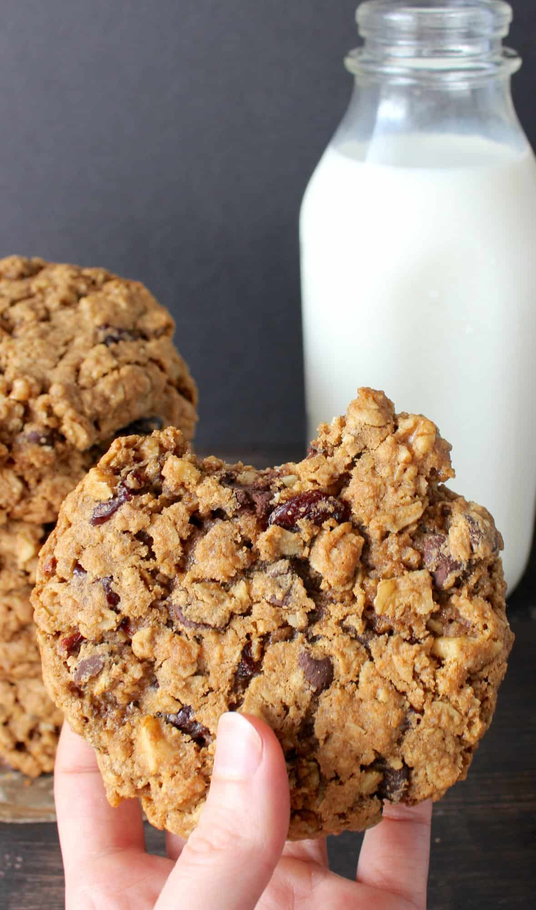
- ½ cup butter room temperature
- ½ cup brown sugar
- ¼ cup white sugar
- 1 egg
- 1 tablespoon Blackstrap Molasses
- ¾ cup flour
- 1 ½ cup rolled oats
- 1 teaspoon cinnamon
- ½ teaspoon baking soda
- ½ teaspoon salt
- 2 teaspoon cornstarch
- ¾ cup dried cherries
- ½ cup chopped walnuts
- ½ cup dark chocolate chips
Instructions
- Preheat the oven to 350° and line 2 sheet trays with parchment paper.
- In a small bowl, combine flour, oats, cinnamon, baking soda, salt and cornstarch. Set aside.
- In a large bowl, cream together the butter, brown sugar, white sugar, egg and molasses. Stir until completely smooth. Add in the dry mixture and stir until evenly mixed. Add in the cherries, walnuts, and chocolate chips and mix in.
- Portion cookie dough into ⅓ cup balls and roll in between palms to make round. It will make exactly 8 cookies.
- Cook 4 on a tray, but only 1 tray at a time. Space evenly and bake for 15 minutes. Press down lightly on the cookies and bake for another 3-5 minutes. Let cool and store in an airtight container.

