Mondo Bag: A Quiltsmart pattern
Date: May 15th and May 29th from 10:30 to 2:30
(bring something to eat)
Instructor: Sandy Lueth, a quilting enthusiast
Quiltsmart is a fusible interface pattern available at Wild Oats
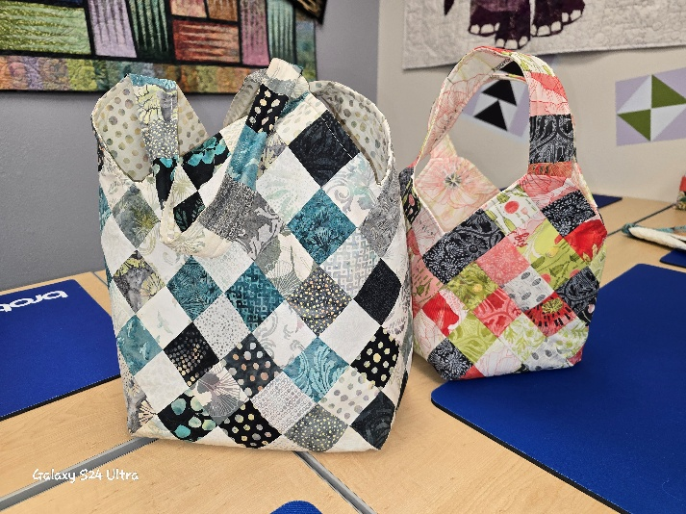

I suggest the larger Mondo bag for your first one. It will be easier during construction of the lining and bag.
After that you can work your way down to the smaller bags.
- Choose your fabrics according to the directions on the pattern
- It’s confusing. Let me help. . . . .
  - The large Mondo Bag (the one I use the most) takes 192, 2 ½ squares. A few extra squares are always good in case they don’t land exactly where you want them. This count does include the handles.
  - You can cut those squares out of 12, 2 ½ strips of fabric
    - That will only take a portion of a Jelly Roll (make 2!)
    - or you can cut your own fabric strips (cutting them a little bigger, is not better)
  - You will also need 1 ¼ yards of fabric for the lining.
  - Please cut the squares at home before the first class. We don’t need to use our fun class time cutting squares.

Class One
Bring your sewing machine and all of your class quilting supplies. You will need an iron and pressing mat.
- Learn how to layout our fabric squares on to the interfacing
- Press them down
- Now we will sew all of our lines to finish up all of the interfacing part.
  - Most of this part (after we learn how) will be done at home.
  - There will be 4 bag sections and 2 handle sections.

Class Two
Bring your sewing machine and regular class quilting supplies.
Yes, you will might want a fusible interfacing in the bag also. There are so many different kinds. You might want a thicker, sturdier interfacing or something thinner. Wild Oats has lot to choose from. We can do that before we start the next steps.
- Bag construction
- Handle construction
- Lining construction
- Putting them all together
- Bragging rights to show off your new bag

These bags are very sturdy. I use mine to take all of my stuff to the gym. After I bring it home with a wet towel in it you can just hang the bag to dry or wash it in cold water.
I throw my small purse in the bag and take it in shopping. I don’t know about you but I always remember my grocery bag (NOW, it took a while to get me trained) but forget them at regular stores. Now you are ready to go.
I’m excited to teach this fun Mondo bag.
If you have any questions before, during or in between classes you can call or email.
Sandy Lueth
970-988-6362
Sandy.lueth@outlook.com

