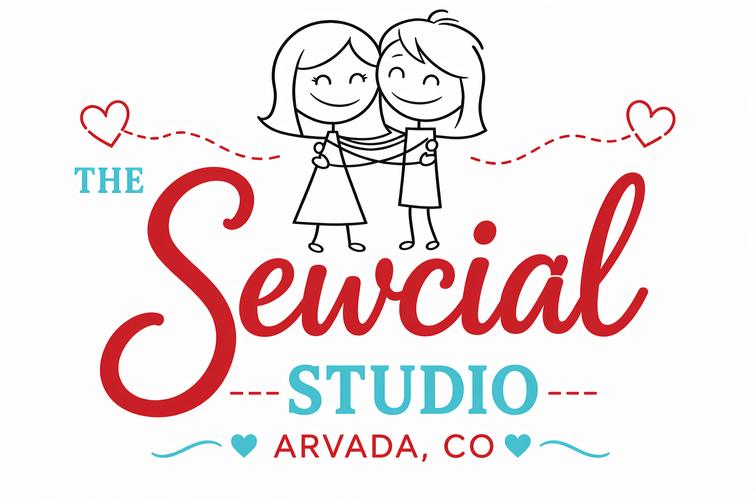
OPEN SEW WAIVER & LIABILITY RELEASE

By signing below, I acknowledge that participation in activities at The Sewcial Studio—including use of sewing machines, irons, cutting tools, and other equipment—carries inherent risks such as cuts, burns, injury, or property damage. I voluntarily assume all risks associated with my participation.

I hereby release and hold harmless The Sewcial Studio, its owners, employees, and affiliates from any and all liability, claims, or damages arising from my use of the studio, equipment, or participation in Classes or Open Sew activities, to the fullest extent permitted by law.

I agree to use only equipment I am trained to operate, follow all posted rules and staff guidance, and report any unsafe conditions or equipment issues. I accept responsibility for any damage caused by misuse or negligence.

I understand that Open Sew is self-guided and does not include formal instruction. I agree to follow all safety practices, including maintaining a clean workspace and wearing appropriate attire. Sewcial Studio is not responsible for lost, stolen, or damaged personal belongings.

I agree to indemnify and hold harmless The Sewcial Studio from any claims resulting from my actions in the studio.

Photo Release (optional):
☐ I consent to the use of photos/videos for marketing
☐ I do not consent

I have read and agree to this waiver.

Name: __________________________
Signature: __________________________ Date: __________

Emergency Contact (Name & Phone): __________________________

