Paradise Sewing
Class Supply List

Pillows for All Seasons – Happy Independence Day
Teacher: Janet Flinn
Paradise Sewing, Poway
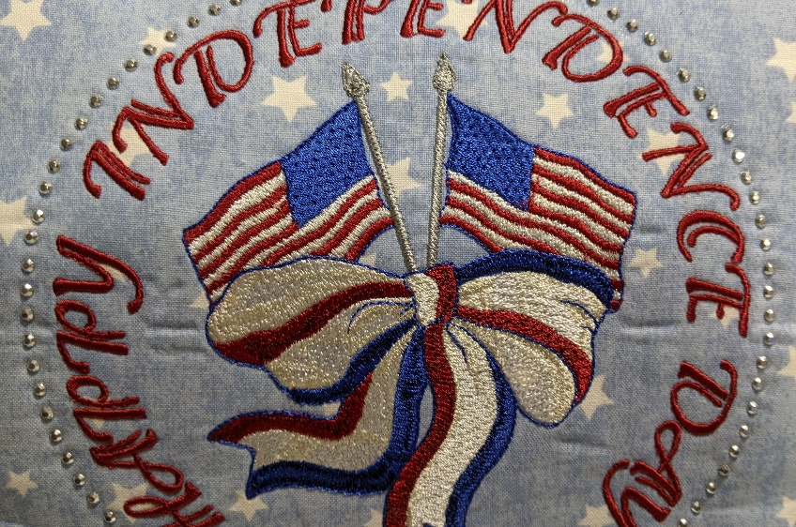
Wed. June 26, 1:00pm – 4:00pm
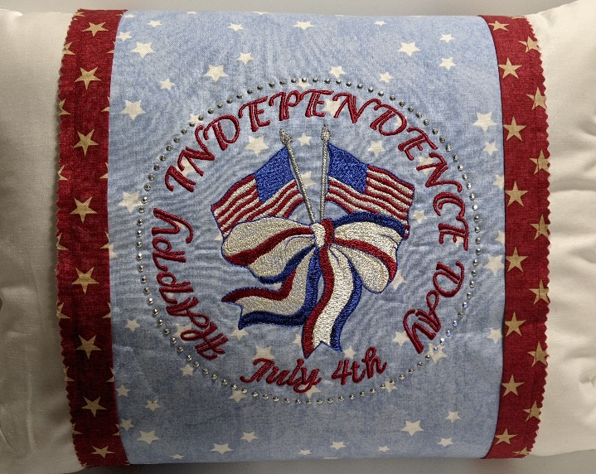
Class $25.00 Kit $15.00**
If using your own fabric, fuse fleece to fabric before embroidering design on fabric.
**Fabric Kits. Call the store and be the first to reserve one. Extra kits can be purchased but must be ordered and paid for at time of registration.
Please register early. Only 8 student per class due to Covid. Masks required

Supply List:
Pillow Cover
- Fabric 1 pc. 10” x 28”
- Floriani Light Fusible Fleece 1 pc. 9” x 27”
- Fabric for strips 2 pcs. 2” x 28”
- Sewing thread & Bobbin*

Floriani Thread colors:
- PF366 Blue Jay*
- PF850 Lamp Light*
- PF4321 Pearl*
- PF483 Light Gray*
- PF485 Gray*
- PF731 Sandstone*
- PF715 Antique Bronze*
- PF358 Navy Satin*
Production Supplies:
- Choco Liner (White) *
- Water soluble Marking Pen *
- Rotary Cutter with Sharp blade *
- Small Travel Iron & Pad. * We will be pressing inside the hoop.
- Embroidery Machine & Unit in good working order *
- Sewing Machine (preferably with sideway stitching) with buttonhole foot**
- 8” x 12” Hoop *
- Floriani Chrome Microtex 80/12 Needles *
- Floriani Perfect Stitch stabilizer *
- Pencil or pen *
- Basic Sewing Supplies, i.e. pins, hand Needles, cleaning brush, etc.*
- Sharp Shears *
- Hot Fix Rhinestone Applicator Wand *
- 94 Silver Hematite STUDs-3MM
- (3) 1” Buttons (2 or 4 holes)

All supplies with an * are available for purchase at Paradise Sewing.
**If you have an Embroidery/Sewing Machine you are covered. If you have Embroidery Only machine, please contact teacher Text or Call (760-458-5934), or flinnscustomcreations@gmail.com

