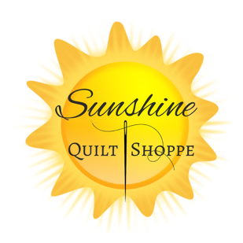
Rabbit Table Runner
Fabric Requirements
Sunshine Quilt Shoppe Rabbit Table Runner Kit - OR

White Background Fabric – ½ yard
Green Background Fabric – ½ yard
Bunny Fabric – Fat Quarter (3 colors)
Binding Fabric – Fat Quarter
Backing Fabric – ½ yard
Batting
Rabbit Table Runner Digital Designs by Stitch Delight (Please use our website, click on affiliate links, and click on Stitch Delight to purchase this design and load to a USB prior to class)

Other Supplies to bring to class
Embroidery machine in good working condition.
5x7, 5x8, or 7x12 embroidery hoops. (For those of you who want to try sizing up your design in your machine, bring a bigger hoop to accommodate for the size adjustment)
No show mesh stabilizer
Thread to match your fabrics and bobbin thread (Sample uses Yellow, Blue, Pink, White and Green)
Snips and applique Scissors
Extra Needles
Rotary cutter and rulers
Please precut your fabric prior to class
(these measurements are for the larger designs that fit in a 7x12 hoop)

White Background Fabric –
Cut 5 squares of 6 ½”
Cut 10 rectangle of 8” x 3 ½””
Green Background Fabric –
Cut 5 Squares of 8 ½”, and crosscut them into 4 triangle, for a total of 20 triangles.
Cut 3 one inch strips by WOF
Bunny Fabrics –
Cut 5 Squares of 8 ½”
Scallop Fabric –
Cut 10 rectangles of 8” x 3 ½”
Binding Fabric –
Cut 2 ½” strips and sew together to prepare your binding. Iron in half lengthwise.

