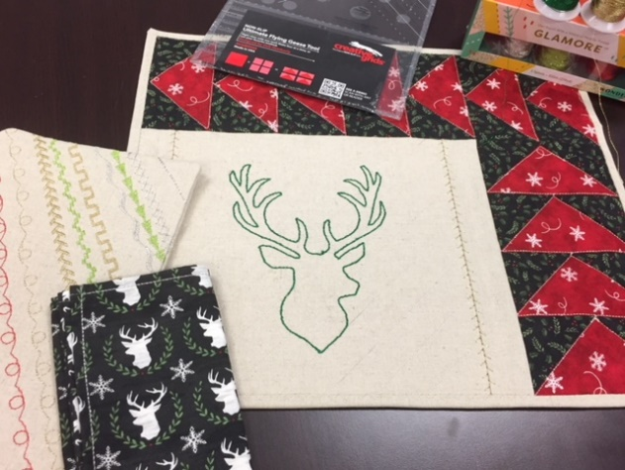
Oh Deer! Flying Geese
Placemat
Supply List
Yardage is based on a set of 4 Placemats

- ½yd (Red) inner goose
- 5/8yd (Black) outer goose
- 1 ¼ yd (Linen) Deer background and binding
- 1yd (printed deer) placemat backing
Notions
- Ultimate Flying Geese tool ruler by Creative Grids
- 1/4” foot and edge stich/stitch in the ditch foot
- 12wt thread / GlaMore thread by Wonderfil
- Topstitch 100/16 needle
- Rotary cutter and mat
- Invisafil 100wt thread that blends with deer background
- Decobob 80wt thread for bobbin by Wonderfil

