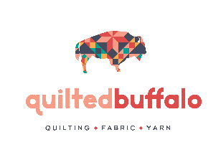
605.673.2728
36 S 6th St
Custer, SD 57730
stacy@quiltedbuffalo.com

Date: Time:

Name: Phone: Address:
Email:

Name of Quilt:

Size x

PLEASE MARK THE TOP OF BOTH QUILT TOP AND BACK WITH SAFETY PIN!

YOUR BACKING MUST BE 3” TO 4” WIDER THAN THE QUILT TOP ON ALL 4 SIDES!

Pattern Selection:

Thread Color:

Batting (Please Circle Choice)
Provided
Pellon 80/20 off-white ($10.99 yd)
QuiltersDream Select Wool ($17.99 yd)
QuiltersDream Select 80/20 White ($10.99 yd)

Binding (Please Circle Choice)
No
Yes- Binding made and included please attach to front (.12 per inch for front / .17 per inch for front and back)
*Binding must be 2.5” strips or enough fabric provided for 2.5” strips*
Please trim my quilt: There is no charge to trim.
Yes No

Please iron my quilt: $25. 00 per hour
Yes
No

Price:
Edge to Edge Quilting 0.025 per sq. inch
Custom Quilting 0.05 per sq. inch
$3 per bobbin
$15 to piece back and /or batting
$25 per hour for any work needed for quilting (removing loose threads, squaring and seam repair).

