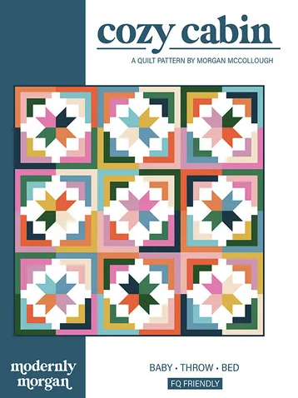

Taught by: Whitney
Date: Saturdays July 1 & 8 (1-4pm)
Cozy Cabin is a fat quarter friendly pattern that combines classic log cabin and star elements to create a modern design. Easily adaptable for use with scraps, Cozy Cabin is sure to become your new favorite quilt! Pattern comes in Baby, Throw and Bed sizes and is great for advanced beginners and up.

Supplies:
- Rotary cutter and mat (we also have mats for use at the store)
- Fabric- this pattern is scrap friendly but also is great for fat quarters- see pattern for amount needed
- *optional* quarter inch ruler or diagonal seam tape for scant ¼” measuring

Skills we focus on:
This class focuses on using a scant ¼” seam allowance and chain piecing.


