Stitcher’s Suitcase - A By Annie Class
with Rita Partridge
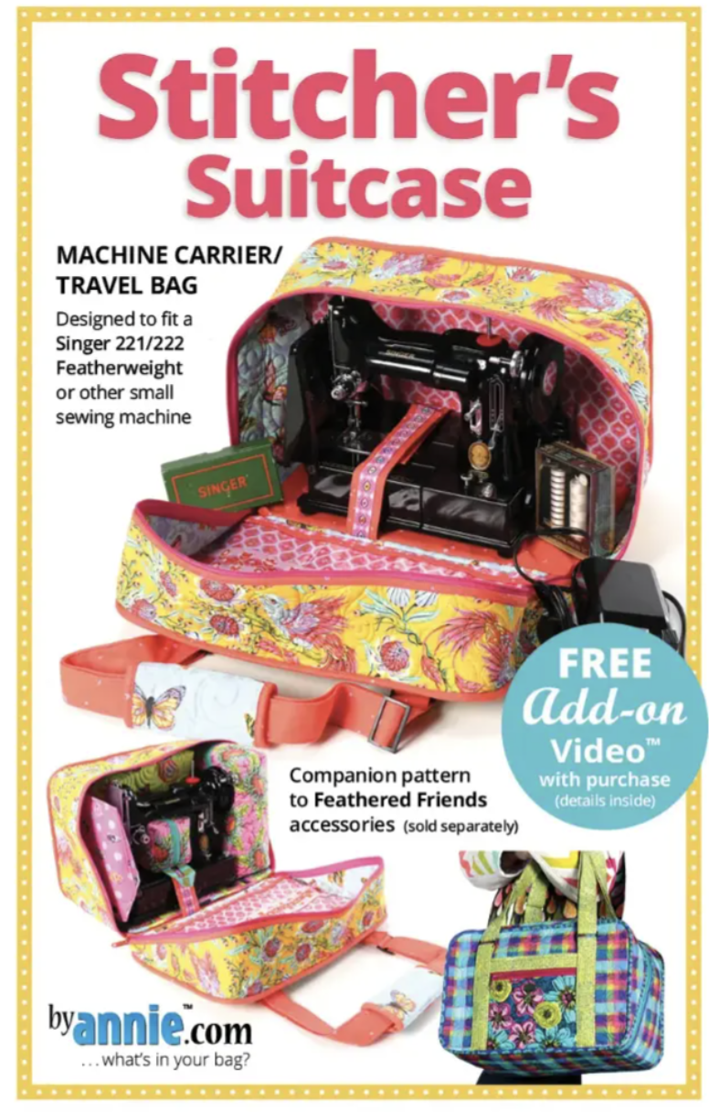
Read through all of this list before starting your shopping!!

Supplies

* “Stitcher’s Suitcase” pattern.
* Read over the supply list on the back of the pattern. Purchase all the necessary items on this supply list.
* Thread to match your Main, Lining and Coordinating fabrics. This may mean three different colors!

Before Class Preparation

* Read Section 1, “Cut and Quilt.” Follow these steps as they are written and complete this section before coming to class. This includes cutting all the pieces needed to complete the bag, and Quilting the main fabric, lining fabric and Soft and Stable. The last page of her pattern is a label sheet. Copy it and attach the labels to the pieces as you cut them out. Do not pin the label to the vinyl-use a clip or leave that one label off.

If you do these steps before class you will be able to get right into the construction of your bag. It will maximize your time with me in class.

General supplies:
* Sewing machine and instruction manual
* rotary cuter, mat and ruler
* Scissors
* Pins or Clips (both if you have them!)
* Marking tool - this can be chalk markers or disappearing pens
– be sure to test disappearing pens on your fabric first!
* Any other favorite sewing tools you use often

I use bias tape makers, turning tube tools, acrylic circles: 2.5” and bodkins when making these bags. I bring these to class to share but if you have any of them bring yours.

