Beginner Hand Appliqué with Rita Partridge

Learn to hand applique with this Laundry Basket Quilt block. In class we will learn how to prepare your fabrics for appliqué and learn a blind appliqué stitch. Tips for success will be discussed and demonstrated as you create this block which can be used for a wall hanging or a pillow.

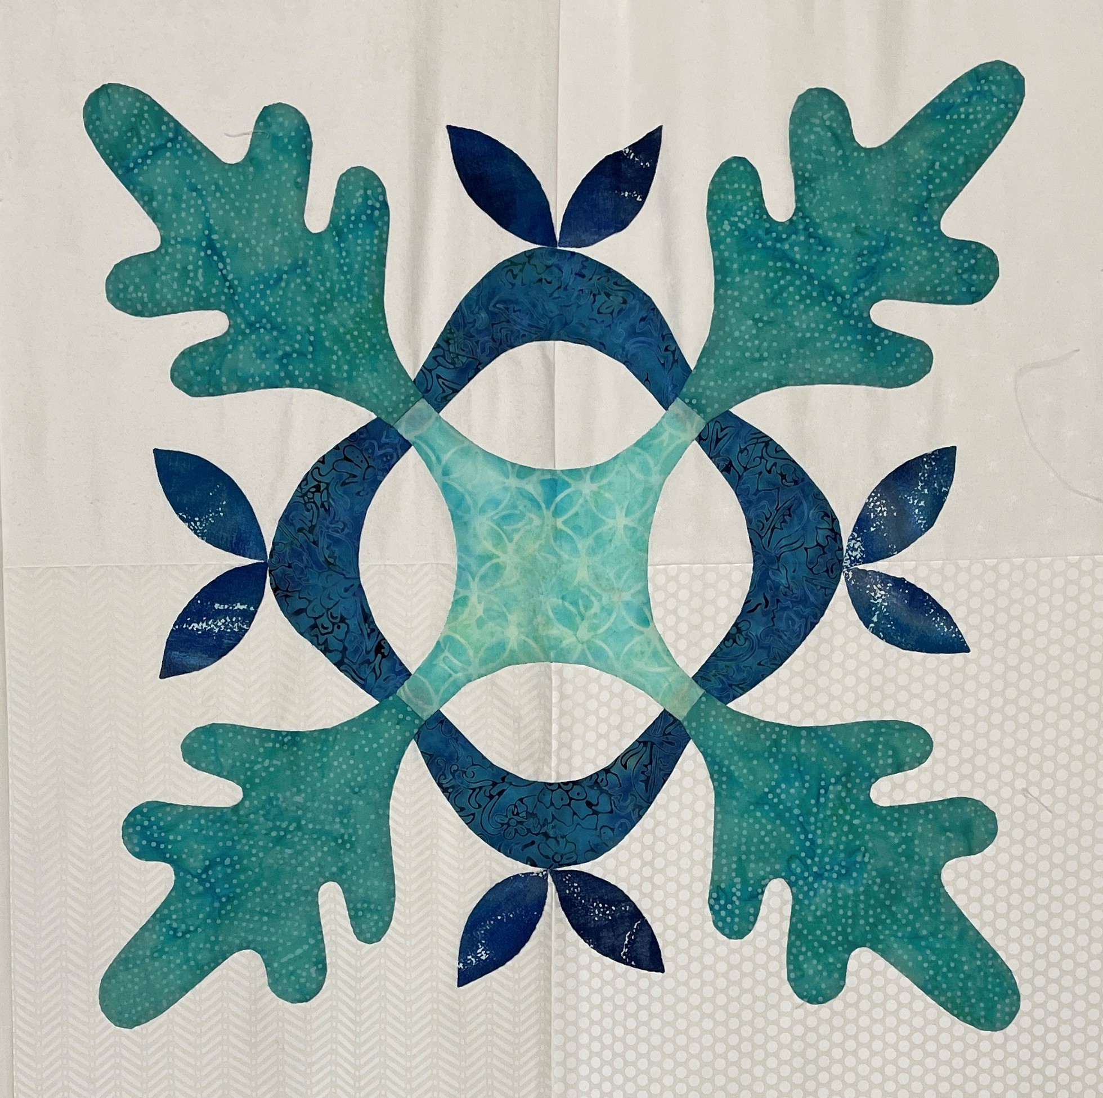
Supplies:

* Thousand Oaks Quilt Pattern by Edita Sitar
* 1 piece of light fabric, 2/3 yd for front and back. See note below!
* 4 fat quarters of assorted blue fabrics
* Hand sewing needles, betweens or milliners, bring what you are most comfortable sewing with.
* 60 wt cotton thread in blue to match your fabrics.
* freezer paper
* pencil

Optional items:
* Thimble, Marking tools, Needle threader, and any other basic sewing tools you use frequently

Note:
The front of the pillow can be done in four pieces of similar color, you will need 4 fat quarters of a light background fabric to piece this pillow front.

If you choose to piece your background, prepare the background piece before class. Cut 4 10 1/2” squares and sew them together. Press your seams open.

