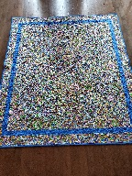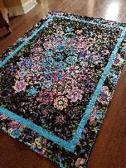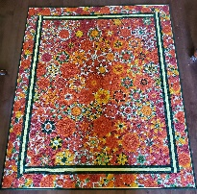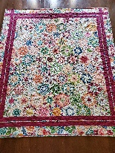

One Block Wonder (OBW)

Select fabric. The design should be on the large side…small designs do not work well. You will need enough fabric to get six repeats of the fabric. I usually get six to seven yards to have sufficient fabric to use as boarder sashing. I also purchase an addition plain fabric to frame the blocks.
Cut the repeats (total of six).
Align to repeats.
Cut the fabric into strips (3.75 wide).
Cut the strips into triangles (60 ° triangle).
Constructing the blocks.
Sort and design.
Number and pin the rows.
Joining the rows.
Even up the sides.
Finishing touches.
Items needed:

Fabric - four to six yards for OBW and boarder sashing; contrasting fabric for boarder.
Rotary cutter
Cutting mat
Long ruler
Flat pins
Handful of large safety pins
60° triangle ruler
Thread
Sewing machine
Scissors

About Lorna Vickers
I started quilting in 2017 after retiring. My first quilt was a queen size disappearing nine patch which I found the design on Pinterest. I thought I can do this! So, I ventured out to the internet to find videos to teach me about this quilting adventure that I was embarking on. By far my most favorite quilt to make is the one block wonder. No two one block wonders are same. It looks complicated but is rather simple. I am excited to have the opportunity to share what I have learned about making this quilt with others.

