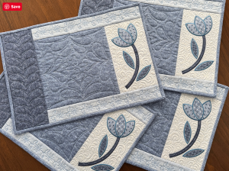
Bernina B990
Placemats
By Amanda Murphy

Supply List:
Fabrics:  3/8 yard for applique background  3/8 yard for top and bottom borders  1 yard for center block, leaves and binding  1/2 yard for left border and stems  1-5/8 yard for tulips and backing | Embroidery Supplies:  Embroidery foot #26L and high tension bobbin case  Oesd press cloth  Oesd fusible woven  Oesd ultra clean and tear (20” wide)  Oesd softweb  Oesd expert embroidery tape  Isacord threads to match and/or contrast
Quilting Supplies:  Adjustable rulerwork foot #72 or 72s  90/14 jeans needle  Thread to match and/or contrast for quilting (recommend Oesd perfect quilting thread)  Amanda Murphy Good Measure Every Semicircle Set 2 Quilting Templates  Amanda Murphy Good Measure Every Angle or Every Angle Plus Quilting Templates  Batting 48”x38” | Sewing Supplies:  Open embroidery foot #20/20C (optional)  Patchwork foot #97D

