FIber U 2018  Fiber-U 2018 is now in the record books. The event was awesome. Thank you to everyone who participated at this year’s event. Students, shoppers, vendors, instructors, and volunteers. We couldn’t have done it without you!  In the last newsletter I mentioned Fiber U was one of the finalists in the Ashford Textiles Competition. We did not win, but as one of the finalists we received $250 in product, and will be featured in this year’s issue of “The Wheel” which will be released in October.  We chose an Ashford Rigid Heddle Loom as our prize and raffled it at the Fiber U event. The proceeds will go to funding scholarships to Fiber U in upcoming years.  [Grab your reader’s attention with a great quote from the document or use this space to emphasize a key point. To place this text box anywhere on the page, just drag it.] |  | Address: 203 Racine Drive  Suite #207  Wilmington, NC 28403  Phone: (910) 833-7005  Hours: 11 am – 4 pm Wed - Fri  And 1st & 3rd Saturdays  Email:  FleecesToPieces@gmail.com  Facebook: Fleeces To Pieces  Website:  - www.FleecesToPiecesOnline.com  - July 2021
Quality Yarn Fiber Workshops Alpaca Apparel | F | In This Issue: Introduction, Opening sale, classes, local artist spotlight

Quarterly Newsletter

This will be my first summer in Wilmington. I am very excited to spend time at the beach and explore the city. Already, I am finding many venues for the arts across town. What could be a blessing in disguise for Fleeces To Pieces is that there seems to be a lot of rain and a lot of hot muggy days. When forced indoors, fiber artists love to do their thing! Fleeces To Pieces would love to help you with that. Let’s make Fleeces To Pieces YOUR local yarn shop!

What’s New at the shop?
Over the last few months the first Fleeces To Pieces Knit / Crochet along was initiated. It is very informal, but a good way to work on a challenging project and share your experiences. You choose the pattern and the yarn of something that you would wear on a cool breezy evening. Just send in pictures and comments. Thursday afternoon Sit & Knits have been started if you want to work on your projects together. There are already about 8 artists participating, and it is not too late to join. I will track progress and post pictures in my website through the month of August. Check it out!
I am planning a fall knit along. The knitting will begin in October. This one will be quite different than the first. Everyone will be knitting the same pattern…with some opportunities for adjustments. Details will be coming in August, with knitting beginning in October. STAY TUNED!
Since the last newsletter I got in Uneek Cotton by Urth yarns. The colors are similar to their wool version, but in a cooler cotton fiber. It is DK weight in 275 yard skeins. I also got a few Pazar Market Bag Kits using this yarn.
A customer requested some Moonshine yarn from Juniper Moon Farm. This is a lovely alpaca/wool/silk worsted weight yarn in 197 yard skeins. The colors are vibrant, and it is oh so soft!
Backordered Berroco’s Summer Sesame came in, and it is beautiful. One customer is already knitting with it, and loves the self-striping.
I just finished inventorying a large order of Frabjous Fibers and Wonderland yarns. It included roving, bulky, worsted, sport, sock, and fingering yarns. I got a pretty good deal too, so I am going to pass the savings on to you! Through the month of August, all Frabjous Fibers and Wonderland yarns will be 20% off! Come in and take a look at their fabulous colors!
I ordered several colors of Malabrigio Rios. It comes in 210 yard skeins of pure merino superwash DELIGHT! Just got notified that this order has shipped, so you Malabrigio fans will be anxious to take a peek. They do beautiful dyeing.
Don’t forget, if there is any yarn that I brought with me and can no longer order, including my farm yarn, it will go on my discontinued “Roll The Dice” sale at the shop. 20% off…AND…if you choose to roll the dice, your discontinued yarn could be as much as 60% off! Stop by and look around for some great deals.

Local Artists Spotlight
If you are a fiber artist in the area and would like to be in the spotlight, stop by and let’s talk!

Events
There are so many things going on this quarter to keep us fiber artists active.
- Christmas in July Sale – July 21 – July 31. All yarn will be 15% off!
- Naughty Or Nice Challenge – Join the challenge for a chance to earn a $20 gift certificate before Christmas. Here’s how!
- Ocean Breeze Knit/Crochet Along continues through August. Participants will be making a poncho or shawl of their choice. If you sign up to participate, any yarn you buy for the Knit Along will be an additional 10% off (Discontinued and Sale items INCLUDED)! This is very informal, but the intention is to choose something that challenges you and that you can share your experience and pictures.
- I Did It My Way Knit Along will Kick off in October. Details coming soon.
- Shop will be closed a few times this summer:
  - July 14 – July 17 (I will be at Fiber U in Lebanon, MO learning some new techniques in dyeing and felting)
  - August 11 – August 13
  - September 16 – September 18

Classes & Workshops
All Classes and workshops will be offered outside of regular business hours to ensure participants get the level of attention that they need.
Beginning Knitting, $50, consists of 6 hours of one on one lessons. I like to divide this time up into 2 or 3 sessions so that you can practice what you learned. Yarn and tools purchased for the class are 25% off, but you are welcome to bring your own if you have them. If you and one or two friends would like to take the class together, there will be a $10 gift certificate per student. Maximum of 3.
Etc…Workshops, (Exploration in Texture and Color) $42/$52, I am offering a series of workshops at the Leland Cultural Arts Center on Thursdays from 5:00pm to 8:00pm. https://www.townofleland.com/lcac
- July 8 2021 Cables – learn how to use a cable needle to twist your stitches into a beautifully textured product.
- August 12 2021 Fair Isle – This 2 color technique allows you to design almost any repeating pattern into your project.
- September & - Beginning Knitting
- October
- November -

******************************
Please bear with me as the website continues to develop. I will be offering most yarns on-line. I have a completely different website, and inventory tracking system. Slowly but surely I will learn this new system, and everything will be entered. In the meantime, if you need anything, please call, email, or drop by!

******************************

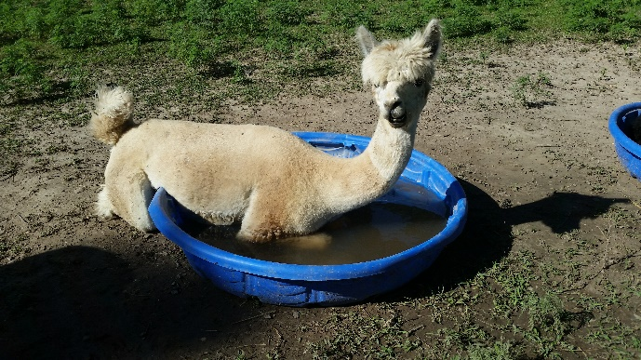
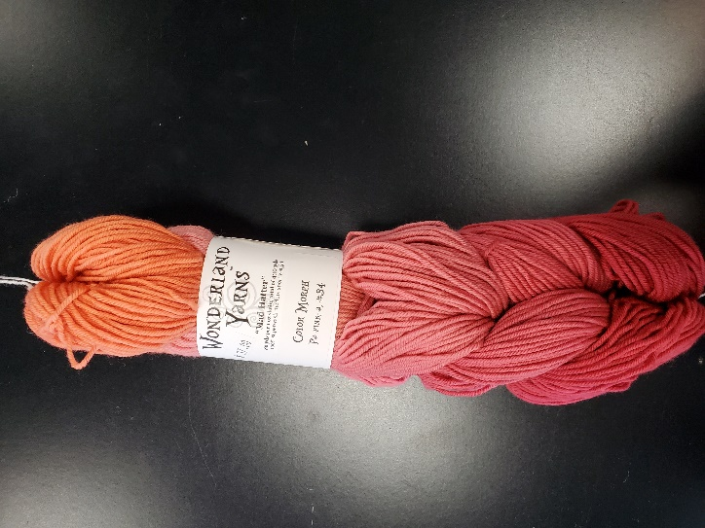
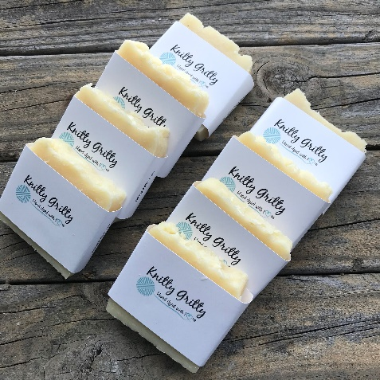
Check the calendar on www.FleecesToPiecesOnline.com

