What Households Can Expect When Census Workers Come to a Home
The Census Bureau will provide face masks to census takers and requires that census takers wear a mask while conducting their work. They will follow CDC and local public health guidelines when they visit. Census takers must complete a virtual COVID-19 training on social distancing protocols and other health and safety guidance before beginning their work in neighborhoods.
People are encouraged to cooperate with census takers and ensure that everyone who was living in their household as of April 1, 2020, is counted. Census takers are hired from the area, and their goal is to help ensure everyone in a home is counted in the 2020 Census. The workers will be collecting household information on their hand-held device (iPhone). All census takers speak English, and many are bilingual. If a census taker does not speak the household’s language, the household may request a return visit from a census taker who does. Census takers will also have materials on hand to help identify the household’s language. If the household needs language assistance they will be encouraged to call the Census phone lines that are staffed with speakers in English and 12 other languages. Anyone 16 years or older may answer the questions for the residence. A younger child may help translate for an older member of the household.
If no one is home when the census taker visits, the census taker will leave a Notice of Visit with information about how to respond online or by phone. If the household responds online or by phone after receiving the Notice of Visit, a census taker is less likely to have to visit the home again to collect a response.

Phone lines are open every day from 6 a.m. to 1 a.m. Central Time
LANGUAGE | LINE TOLL-FREE NUMBER
English | 844-330-2020 Prompts
Spanish | 844-468-2020 Prompts
Chinese (Mandarin) | 844-391-2020 Direct Answer by a Representative
Chinese (Cantonese) | 844-398-2020 Direct Answer by a Representative
Vietnamese | 844-461-2020 Direct Answer by a Representative
Korean | 844-392-2020 Direct Answer by a Representative
Russian | 844-417-2020 Direct Answer by a Representative
Arabic | 844-416-2020 Direct Answer by a Representative
Tagalog | 844-478-2020 Direct Answer by a Representative
Polish | 844-479-2020 Direct Answer by a Representative
French | 844-494-2020 Direct Answer by a Representative
Haitian Creole | 844-477-2020 Direct Answer by a Representative
Portuguese | 844-474-2020 Direct Answer by a Representative
Japanese | 844-460-2020 Direct Answer by a Representative
Telephone Display Device (TDD) | 844-467-2020

How to Identify Census Takers
Census takers can be easily identified by a valid government ID badge with their photograph, a U.S. Department of Commerce watermark, and an expiration date on the badge. To confirm a census taker’s identity, the public may contact their regional census center to speak with a Census Bureau representative. For the Chicago Region, 312-579-1500.

How Can You Verify That Someone Is a Census Taker?

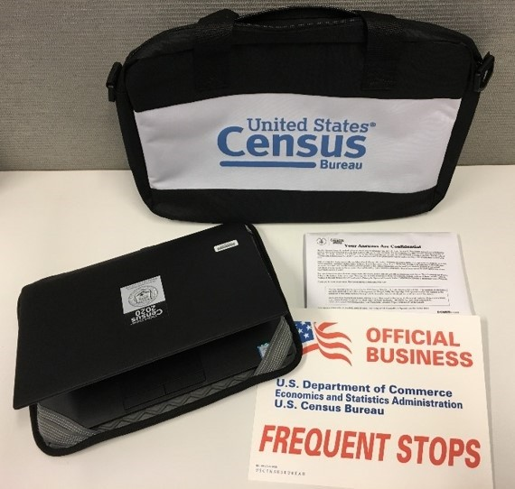
If someone visits a home this year to collect information for the 2020 Census, the resident should check to make sure the worker has a valid ID badge with their photograph, a U.S. Department of Commerce watermark, and an expiration date. Census workers may also carry Census Bureau bags and other equipment with the Census Bureau logo.
A look at some of the items that a census taker may carry with them, including, laptop bag, confidentiality notices, and an "Official Business" notice for their vehicle.

Staying Safe at Home
If someone visits your home to collect a response for the 2020 Census, you can do the following to verify their identity:
- First, check to make sure that they have a valid ID badge, with their photograph, a U.S. Department of Commerce watermark, and an expiration date.
- If you still have questions about their identity, you can call 844-330-2020 to speak with a Census Bureau representative.

