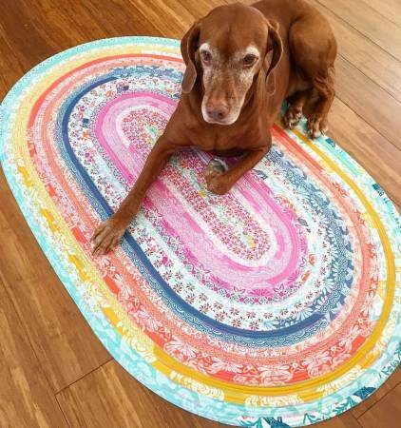
My Fabric Friends, 105 Cozzi Circle, Victoria, TX 77901 (361) 894-6816

Supply List for “Faux Braid” Rug Class
November 18, 2025 @ 9:00-3:00 pm
Instructor: Marcia Neely
Class: $35

You will need a pattern to take the class. We have them available in the store if you do not already have one.

Fabric:
- 1 Jelly roll (40-42 strips of 2.5” x WOF)
- 2.25” or 2.5” roll of batting, 50-yard roll

Other Requirements:
- Jellyroll Jig highly recommended (available at My Fabric Friends).
- Sewing machine in good working order and makes adjustable zig-zag stitch
- #14-18 Blue Jean sewing needle
- Thread to match fabric or neutral color; wound bobbins. You will need at least 1200 yards. Consider variegated thread, it’s so pretty!
- WALKING FOOT is a must have. Make sure it has the zigzag opening for the needle to work.
- Rotary cutter & mat
- Large fabric clips or Pins, if you are so inclined
- Optional: A large sewing table attachment is highly recommended; it makes the construction of the rug much easier to manage.

BEFORE coming to class, you can do following to save time:
- Sew ALL strips together end-to-end into 1 long strip (like making binding)

Please contact the store if you have any questions or concerns at 361-894-6816

CLASS POLICIES:
- Please do not bring visitors to class.
- Be sure to check your supply list before class. Bring all supplies with you. Please label all supplies with your name.
- No Refunds unless My Fabric Friends cancels a class due to insufficient participation. If we cancel the class for this reason, you will receive a full refund of the class fee. (You can avoid this situation by getting a friend to sign up with you! 🙂)

