
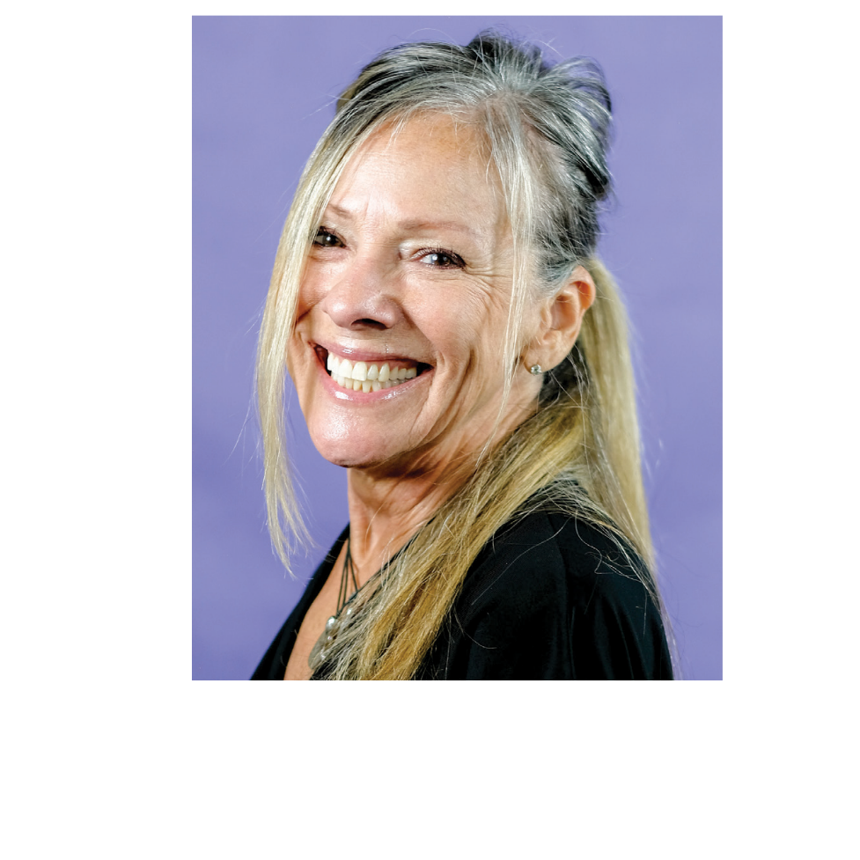
NATIONAL
EDUCATOR

LORETTA MORRIS

Loretta’s rst experience with a sewing machine was in junior high school where
she made a pair of powder blue corduroy overalls. Those overalls were loved so
much by all of her friends that she ended up giving them to her, at the time, best
friend Janey.
She didn’t touch a sewing machine for the next 10 years or so, until her
mother-in-law gave her a sewing machine as a gift, and she thought,
“What am I going to do with this?” So she did the only thing she thought she
could do, she began making clothes for her children, and then she began making
them for herself. She then ventured into rag doll making, selling those dolls at
craft shows, and teaching at her local quilt shop. It was there that she laid her
eyes on a quilt that she just had to make, so she talked the maker of that quilt
into teaching a class, and so began her love of Quilts.
Loretta started doing her own quilting on a HQ Sweet Sixteen® and graduated
to the Amara® with Pro-Stitcher® 5 years later. She has enjoyed teaching others
the love of quilting ever since.
She loves art quilting as well as traditional quilting, and combining free motion,
ruler work and Pro-Stitcher to create custom quilting.
Loretta has 4 grown children and 12 grandchildren.

www.HandiQuilter.com

