Basic Wet Felting
Basic Felting: Learn the basics of Wet Felting: 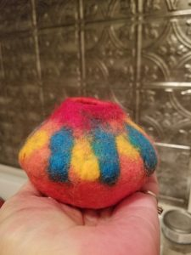
In this class, you will learn the basic techniques for wet felting while working on small samples. You will learn to wet felt while making a small vessel, like the one pictured to the right, a flower (below) and a small piece of felted fabric.
PLEASE BRING 2 LARGE TOWELS
Date:
Instructor: Sandi Kramer

