Fresh Off the Farm
Fabrics in Fat Quarter Pack
7/16/12

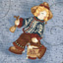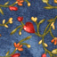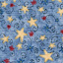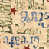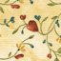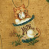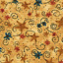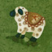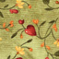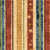
Character squares represent a character toss.

