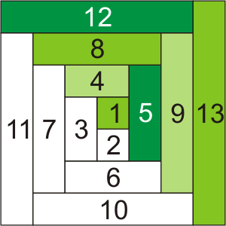
Quick Cut / Quick Sew
Log Cabin

This free pattern is provided by Wimberley Stitch Studio Copyright 2015
Demos and Classes are available by request.

Wimberley Stitch Studio
Linda Chase
704 FM 2325
Wimberley, Texas 78676
512-808-0490
www.wimberleystitchstudio.com

Instead of cutting all those 2 inch strips and then recutting to the correct length, do the opposite…
Cut each fabric to the correct length by the width of fabric. Open fold. Layer in order of sewing. Because of the number of layers to cut. You will have 8 layers. If you’re comfortable cutting 8, continue. If not, divide the layers into two stacks and layer again after cutting. Cut each to the 2 inch width. Safety pin the center 3 in. square to each layer of strips ready to make each block. You will have 20-21 blocks. Sew as usual for log cabin blocks. Repeat as needed. Arrange as desired.
For 12 ½” finished blocks:
Center square: Cut 2- 3 ½”x WOF. Subcut into 3 ½” squares (finish 3”)
Strip 2 & 3, Cut 1- 3 ½” x WOF, Cut 1- 5” x WOF
Strip 4 & 5, Cut 1- 5” x WOF, Cut 1- 6 ½ ” x WOF
Strip 6 & 7, Cut 1- 6 ½ ” x WOF, Cut 1- 8” x WOF
Strip 8 & 9, Cut 1- 8 ” x WOF, Cut 1- 9 ½” x WOF
Strip 10 & 11, Cut 1- 9 ½” x WOF, Cut 1- 11” x WOF
Strip 12 & 13, Cut 1- 11” x WOF, Cut 1- 12 ½ ” x WOF

