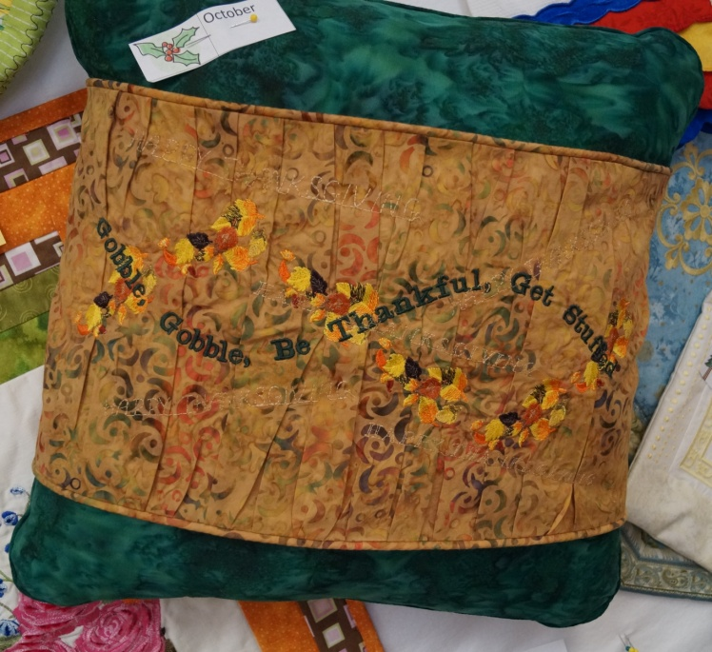
Embroidery Extras October Supply List
Falling Leaves Pillow Wrap

Note: Pattern calls for linen, suede, and packaged piping. Cottons batiks are used on sample and I made my own piping. I also used a purchased pillow form rather than fiberfill.

